Mapping the creative industries in North East Scotland
Aberdeen City Council
Prepared by:
Iain Bennett, The Fifth Sector Limited
Jon Bains, Obsolete.com
Simon Sprince and Andy Goodwin, Unscrambled.world
Lynne McCadden
Final report
June 2026

Contents
Executive summary 1
Part One: Purpose and argument 4
Part Two: A creative economy larger than the statistics record 7
Part Three: A creative economy in four tiers 14
Part Four: The convergence opportunity 17
Part Five: Skills supply and capability 20
Part Six: Aligning data and primary research 25
Part Seven: Cultural sector as economic infrastructure 26
Part Eight: Structural challenges 29
Part Nine: Four growth strategies 32
Part Ten: Five strategic recommendations 35
Conclusion 38
Appendices 39
Appendix A: Methodology 40
Appendix B: Creative skills needs and gaps for Aberdeen city and Aberdeenshire 51
Appendix C: Deemouth Artist Studios and Edit Aberdeen Case Study 60
Appendix D: Options assessment 66
Appendix E: Comparative evidence of the East London creative experience economy 72
Appendix F: References 73

Tables
Table ES.1: North East Scotland creative economy at a glance 2
Table ES.2: Three opportunities and three challenges 3
Table 3: Hidden workforce evidenced by LinkedIn, September 2025 13
Table 6: Market context for the convergence opportunity 19
Table 7: Geographic destination of creative alumni 20
Table 8: Skills position relative to Nottingham comparator 21
Table 9: Capability mirror, North East Scotland and East London 24
Table 12: North East Scotland creative workforce by tier 44
Table 13: FTE intensity factors by tier 46
Table 14: Direct gross value added by tier 47
Table 15: Direct GVA and total economic impact by tier 48
Table 16: Convergence-tier firms by cluster 49
Table 17: Graduate destination by institution (LinkedIn, April 2026) 50
Table 18: Principal skills gaps: summary assessment 53
Table 19: NESCol course portfolio: future skills alignment 55
Table 20: Skills gap matrix: opportunity pathways, evidence and interventions 57
Table 21: Principal articulation pathways: creative and digital subjects 58
Table 22: Recommendation 1- Joint CoSTAR bid 69
Table 23: Recommendation 2 – Joint Cultural and Creative Economy Board 69
Table 24: Recommendation 3 – Align creative economy with energy transition 70
Table 25: Recommendation 4 – Creative Ecology Structural Fund 70
Table 26: Recommendation 5 – Full-spectrum measurement (North East Scotland Culture Data Hub) 71

Figures
Figure 1: Theory of change 6
Figure 2: Three populations of creative and adjacent firms 10
Figure 3: Three-layer evidence method 12
Figure 4: Four-tier creative economy 16
Figure 5: Skills mirror, North East Scotland against Nottingham 22
Figure 6: Churn cycle 30
Figure 7: Recommendation dependency and sequencing 37
Figure 8: Crosswalk and pure adjacent identification 45

Executive summary

North East Scotland has a creative economy of more than 1,400 firms and 10,000+ creative workers, artists, makers, musicians and performers, generating £453 million in direct gross value added and £675 million in total economic impact. Official statistics record fewer than half of these workers; they count only employees in registered firms and miss the freelance and self-employed majority, who make up 52% of the creative workforce.
Workforce evidence draws on four sources: administrative data from the Office of National Statistics (BRES and IDBR); Companies House records; real-time firm classification from The Data City; and LinkedIn workforce profiling, read as a large pre-filled occupational survey. The LinkedIn layer alone found more than 8,400 creative profiles among North East Scotland residents, including 3,280 freelance and self-employed workers absent from official counts. Interviews and workshops held in Aberdeen between October 2025 and April 2026 reached the same structural conclusions as the data, finding by finding.
The region holds a distinctive and previously unexplored asset. Fifty years of safety-critical offshore operations has built an unusually high concentration of simulation skills amongst an pool of 2,300 practitioners, alongside capabilities in production management, visual effects and procedural workflows. These disciplines that underpin immersive content, virtual production and real-time visualisation.
However, the workforce with these skills sits apart from the creative agencies that could take it to market. Registered creative firms hold narrative, client and production capability; energy-domain technical firms hold simulation and visualisation depth. Skills analysis shows the mirror image of each sector in the other: working together, they could address their respective deficits of virtual production and data storytelling, and join technical depth to content creation skills to address new (to North East Scotland) global markets in createch, renewables and energy transition. Many of these firms sit within a few streets of each other in central Aberdeen, yet they have no shared identity or working relationship.
There are strong policy signals to suggest that this is an important, but time-sensitive, opportunity. The UK Government's Creative Industries Sector Plan (2025) names creative technology as a growth priority, projecting £18 billion in gross value added and 160,000 jobs over a decade (DCMS, 2025). Two funding rounds define the window: CoSTAR satellite lab funding, with confirmation expected in June 2026, and the third round of the Creative Industries Cluster Programme (CICP3), expected in January 2027. Creative industries featured in the First Minister's priorities for the new Scottish Government; we might expect faster policymaking signals and more willingness to fund pilot initiatives. The distribution of portfolios in the new administration may suggest new or re‑scoped funding to emphasise skills development, education pathways, and tech/innovation for creatives (e.g., digital tools, creative‑tech R&D, tertiary training).
North East Scotland's tertiary education sector produces the creative and bridging skills the sector lacks, but then loses them. Of 1,527 mapped creative graduates working in the UK, only 46% remain in North East Scotland; most leavers go to Edinburgh and Glasgow.
A dispersed cultural workforce gives the region its distinctiveness but stays largely uncounted and unacknowledged. Some 2,000 artists, makers and musicians generate an estimated £28 million from a base that official statistics record as zero. Their work carries four millennia of heritage, the Doric language and a living craft tradition that external markets recognise as authentically of the place. That cultural foundation is also demographic infrastructure: at the point of energy transition, a region that cannot hold its population declines rather than diversifies. However, North East Scotland receives regular arts funding of only 44% of the Scottish average, with Aberdeenshire even worse off at 27%.
Five recommendations follow, framed as a theory of change and mapped to national funding opportunities, Regional Economic Strategy and Local Outcomes Improvement Plan. Recommendation 1 addresses time-limited opportunities to attract R&D funding for creative content and technologies. A joint cultural and creative economy board (Recommendation 2) is the precondition for three of the others and describes the minimum governance needed to act across two council areas. Tables ES.1 and ES.2 below summarise the economy and the priorities.

Table ES.1: North East Scotland creative economy at a glance
Dimension | Metric | Value | Source
Scale | Total workforce | 10,490 workers | Table 4
 | Direct GVA | £453 million | Table 5
 | Total economic impact | £675 million | Table 5
Four tiers | Tier 1: institutional anchors | 1,210 workers (860 FTE) | Table 4
 | Tier 2: SME commercial core | 3,845 workers (3,445 FTE) | Table 4
 | Tier 3: visible freelancers | 3,400 workers (2,550 FTE) | Table 4
 | Tier 4: invisible workforce | 2,035 workers (860 FTE) | Table 4
Firms | Registered creative businesses | 1,425 (970 pure, 455 mixed) | Table 2
 | Micro-enterprises (under 10 staff) | over 90% of firms | section 2.2
Hidden workforce | LinkedIn creative profiles | over 8,400 | Table 3
 | Freelance and self-employed | 3,280 | Table 3
Skills | Simulation | 3.5x surplus vs Nottingham | Table 8
 | Virtual production | 7.2x deficit vs Nottingham | Table 8
 | Data storytelling | 5.2x deficit vs Nottingham | Table 8
Retention | Combined creative retention | 32% | Table 7
 | RGU creative alumni retained | 36% | Table 7
 | University of Aberdeen retained | 23% | Table 7
Funding | Creative Scotland MYF per head | £5.72 (44% of Scottish average) | Table 9

Source: The Fifth Sector (2026).

Table ES.2: Three opportunities and three challenges

Priority | Opportunities Description | Opportunities  Response | Challenges Description | Challenges  Response
1 | Creative-digital convergence: industrial simulation and visualisation capability translating into creative markets | Strategy 1 | Skills distribution gap: technical depth and creative breadth, short of the bridging capabilities that join them | Strategies 1 and 3
2 | Rural and coastal cultural identity: distinctive craft and tradition creating an authentic place-based offer | Strategy 2 | Graduate retention: 32% combined rate, driven by absence of visible local pathways | Strategies 3 and 4
3 | Graduate pipeline: high volume of creative and digital graduates with unrealised local potential | Strategy 3 | Organisational churn: connective sector on precarious project funding, collapsing when grants end | Strategy 2;  Recommendation 2

Source: The Fifth Sector (2026).

Part One: Purpose and argument
In brief
- Question: What did the brief ask, and how should the report be read?
- What the evidence revealed: The strategic value of the creative economy is wider than a sector map records, and the report's argument runs as a single chain from measurement to action.
- How we addressed it: Part One sets the scope, names the five populations that make up the economy, and states the theory of change that structures Parts Two to Ten.

1.1 Scope and purpose
Aberdeen City Council commissioned this mapping of the creative industries in Aberdeen and Aberdeenshire to inform the place of the sector in the Regional Economic Strategy, guide investment, and set out practical actions for councils, agencies, funders and educators. The result is both an economic mapping exercise and a strategic development study. It measures the scale, composition and value of the creative economy, shows where official data undercounts it, examines how creative, cultural, digital and energy-transition capabilities relate, and recommends action.

1.2 How the analysis answers the brief
The analysis combines official government data, real-time company intelligence, workforce profiling, graduate destinations data, stakeholder consultation and comparative research. Five populations make up the regional economy: institutional cultural anchors; a city-centre commercial creative and creative-digital base; a dispersed rural and coastal practitioner base; a visible freelance workforce; and a set of adjacent technical firms whose simulation and visualisation capability could reach creative markets. Each population is reaching the limit of what it can deliver alone, and the separation between them is institutional, a product of geography, sectoral self-identification and the absence of any mechanism for exchange.

1.3 Strategic implications
The evidence shows that creative industries holds a strategic value wider than a conventional sector map records. Three implications follow. The region holds a competitive position that the Central Belt, London and other UK city-regions cannot easily replicate, combining industrial-scale simulation capability, energy-domain knowledge and rural-coastal cultural identity. The report accounts for economic, social and cultural value together, in line with Throsby and Bakhshi's framework of economic, non-market cultural, and symbolic value; and builds that principle into the measurement framework into its recommendations. Policy should connect digital sectors, creative industries and cultural infrastructure rather than choosing among them, since each needs different intervention at a different timescale. Acting on all three requires a shared mandate, which Part Ten sets out.

1.4 Theory of change
This report is built as a theory of change, with a deliberately sequenced argument (Figure 1).
Measurement comes first. The creative economy is larger than existing frameworks record, and what goes unmeasured goes uninvested. François Matarasso documented the same pattern for Aberdeenshire's cultural sector in 2014. This research establishes the scale of the evidence gap across the wider creative economy twelve years on; it now stands as a barrier to regional, national and global commercial opportunities that did not exist then (Part Four; Appendix C).
North East Scotland holds a comparative advantage in simulation and visualisation skills, built on fifty years of safety-critical offshore operations. That advantage maps onto two opportunities: commercial demand from energy transition for technical communication and public engagement, and a strategic position as a createch hub where creative and technical capability combine to produce new products, services and exports. The UK Creative Industries Sector Plan (2025) frames both, with CoSTAR and the third round of the Creative Industries Cluster Programme (CICP3, expected January 2027) as potential funding routes (DCMS, 2025). The potential to exploit convergence is an observed growth mechanism based on strong market signals rather than a grounded proposition. It finds a parallel in East London's experience economy, formed over thirty years where digital production met live spatial practice in one geography; North East Scotland holds a different combination of ingredients in complementary form at an earlier, more dispersed stage. The London comparison is set out as a reference point in section 5.5, with its provenance and signal strength documented at Appendix E.
Each stage of the theory of change builds on the previous one: measure, recognise, invest, connect, retain. Measurement produces evidence; evidence supports recognition of the sector's scale; recognition enables strategic investment; investment connects capabilities that now operate separately; connection builds the mid-tier employment that makes graduate retention achievable. Early links can begin in parallel, and the full change requires all of them.
Four conditions determine whether the mechanism works: cross-boundary governance, skills infrastructure, cultural infrastructure, and a shared regional narrative. The five recommendations in Part Ten are built around them, and Table 10 maps each finding to the strategy and recommendation it drives. Recommendation 2, a Joint Creative Industries Board, is the precondition for three of the others. The change this anticipates is a growing creative economy that retains its graduates, recognises that culture provides critical infrastructure to sustain the region's population through the energy transition, and contributes creative and communication skills to that transition as a national asset. Whether it happens depends on decisions still to be made.

Figure 1: Theory of change
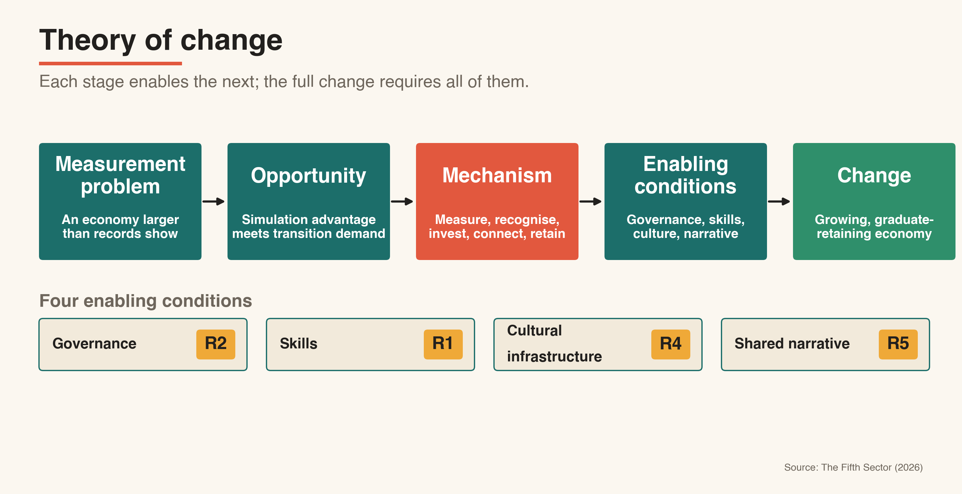

Part Two: A creative economy larger than the statistics record
In brief
- Question: How big is the creative economy, and why do official figures miss most of it?
- What the evidence revealed: Whereas official data record around 4,690 employees, the three-layer method finds 10,490 workers and 1,425 firms, with 3,280 freelance and self-employed creative workers and a further 2,000 artists, makers and performers invisible to payroll data.
- How we addressed it: A four-tier model which maps creative work and supply chains across the whole economy make the full economy visible. Recommendation 5 turns that method into a standing measurement framework.

2.1 What official data misses
National statistics count employment in registered firms. Applied to North East Scotland, that approach records 4,690 creative employees in 2024, of which 1,400 to 1,600 are generic IT consultants serving the wider economy rather than creative markets (BRES 2024; Table 1). The strategic creative core measured on this basis falls to around 3,290 employees, a floor rather than a full count. Self-employed and freelance practitioners do not appear at all.
Table 1: Creative industries employees, Aberdeen and Aberdeenshire
Sub-sector | BRES 2023 | BRES 2024
Advertising and marketing | 255 | 180
Architecture | 400 | 400
Crafts | 20 | 10
Design and designer fashion | 250 | 160
Film, TV, video, radio and photography | 455 | 370
IT, software and computer consultancy | 2,300 | 2,150
Publishing | 270 | 200
Museums, galleries and libraries | 435 | 760
Music, performing and visual arts | 580 | 460
Total creative industries | 4,965 | 4,690
Excluding 62.02 computer consultancy | 1,600 | 1,400
Total for sector analysis | 3,305 | 3,290
Source: The Fifth Sector (2026) analysis of Business Register and Employment Survey, via Nomisweb © Crown Copyright.

2.2 Registered business base
A firm-level crosswalk addresses the business count. Using Companies House and The Data City records against four-digit creative SIC codes used by DCMS to measure the creative industries sector, the research identifies 970 pure creative firms and 455 firms combining creative and adjacent activity in other (mostly) digital and engineering sectors, making 1,425 in total (Table 2; method at Appendix A.2). A two-pass filter removes brass-plate registrations, contractor vehicles, nominee registrations and industrial utility firms, ensuring that the count reflects firms with evidenced creative-digital activity. More than 90% of those businesses employ fewer than ten people.

Table 2: Registered creative business base, 2024-25
Sub-sector | Pure CI | CI + adjacent | Combined
Advertising and marketing | 45 | 20 | 65
Architecture | 105 | 10 | 115
Crafts | * | * | 10
Design and designer fashion | 95 | 45 | 140
Film, TV, radio and photography | 95 | 35 | 130
IT, software and computer services | 390 | 245 | 635
Publishing | 55 | 35 | 90
Museums, galleries and libraries | 50 | 0 | 50
Music, performing and visual arts | 130 | 55 | 185
Total | 970 | 455 | 1,425
Source: The Fifth Sector (2026) analysis of Companies House and The Data City™. Rounded to nearest 5. * fewer than ten firms; suppressed.
2.3 Digital crosswalk
A Standard Industrial Classification records what a firm registered as, often years earlier. It misses firms doing creative-digital work under non-creative codes, and it keeps firms that no longer trade as creative. The crosswalk sets each firm's SIC code against its Real-Time Industrial Classification (RTIC), which The Data City derives from current website content and other live sources. SIC is the registration; RTIC is the evidence of what the firm does now, and the comparison between them is the core test applied in the crosswalk. A two-pass filter then removes brass-plate registrations, personal-service contractor vehicles, nominee registrations and industrial utility firms. Computer consultancy (SIC 62020), the whole of which is recognised as part of creative industries by DCMS, is kept only where there is creative-digital evidence, so generic IT support to the energy sector is excluded.
The method avoids double-counting the digital sector as described in Opportunity North East's report and avoids missing genuine creative-digital activity.The crosswalk sorts firms into three populations (Figure 2). "Pure" creative industries (CI) firms (970) register and trade wholly within creative-industries codes. "CI plus adjacent" firms (455) combine creative codes with adjacent activity, and both count in the headline economy of 1,425 firms. Around 25 "pure adjacent" firms registered outside creative codes show evidenced creative-technical crossover; they are the most strongly evidenced part of a wider adjacent technical population (Group B, around 90 firms across four clusters) examined in Part Four. This population is treated as growth potential and is not counted in the headline economy (Appendix A.2 and A.9).

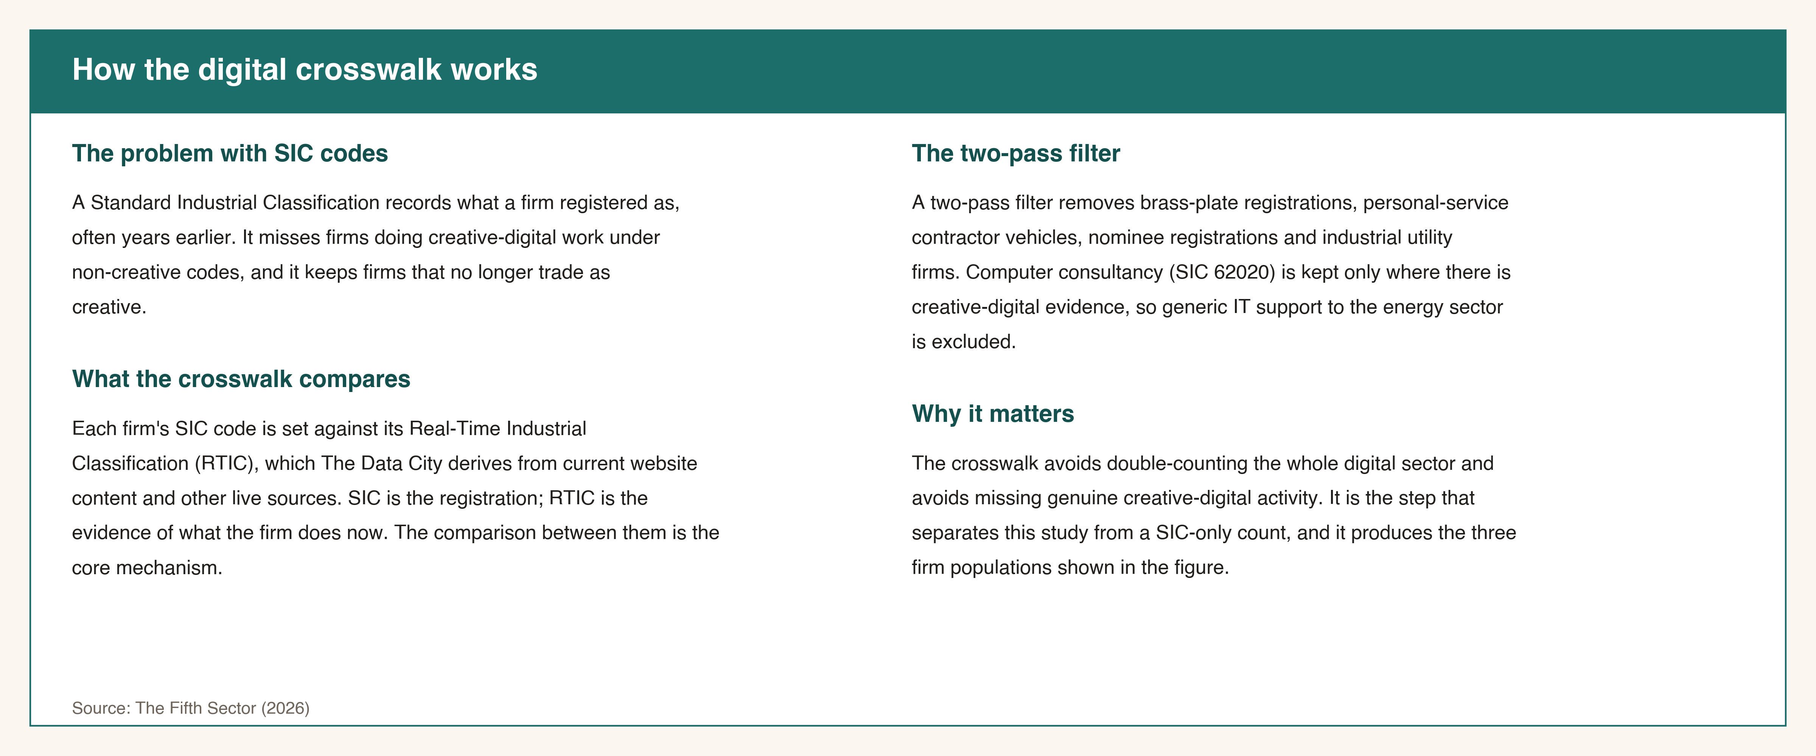
Figure 2: Three populations of creative and adjacent firms
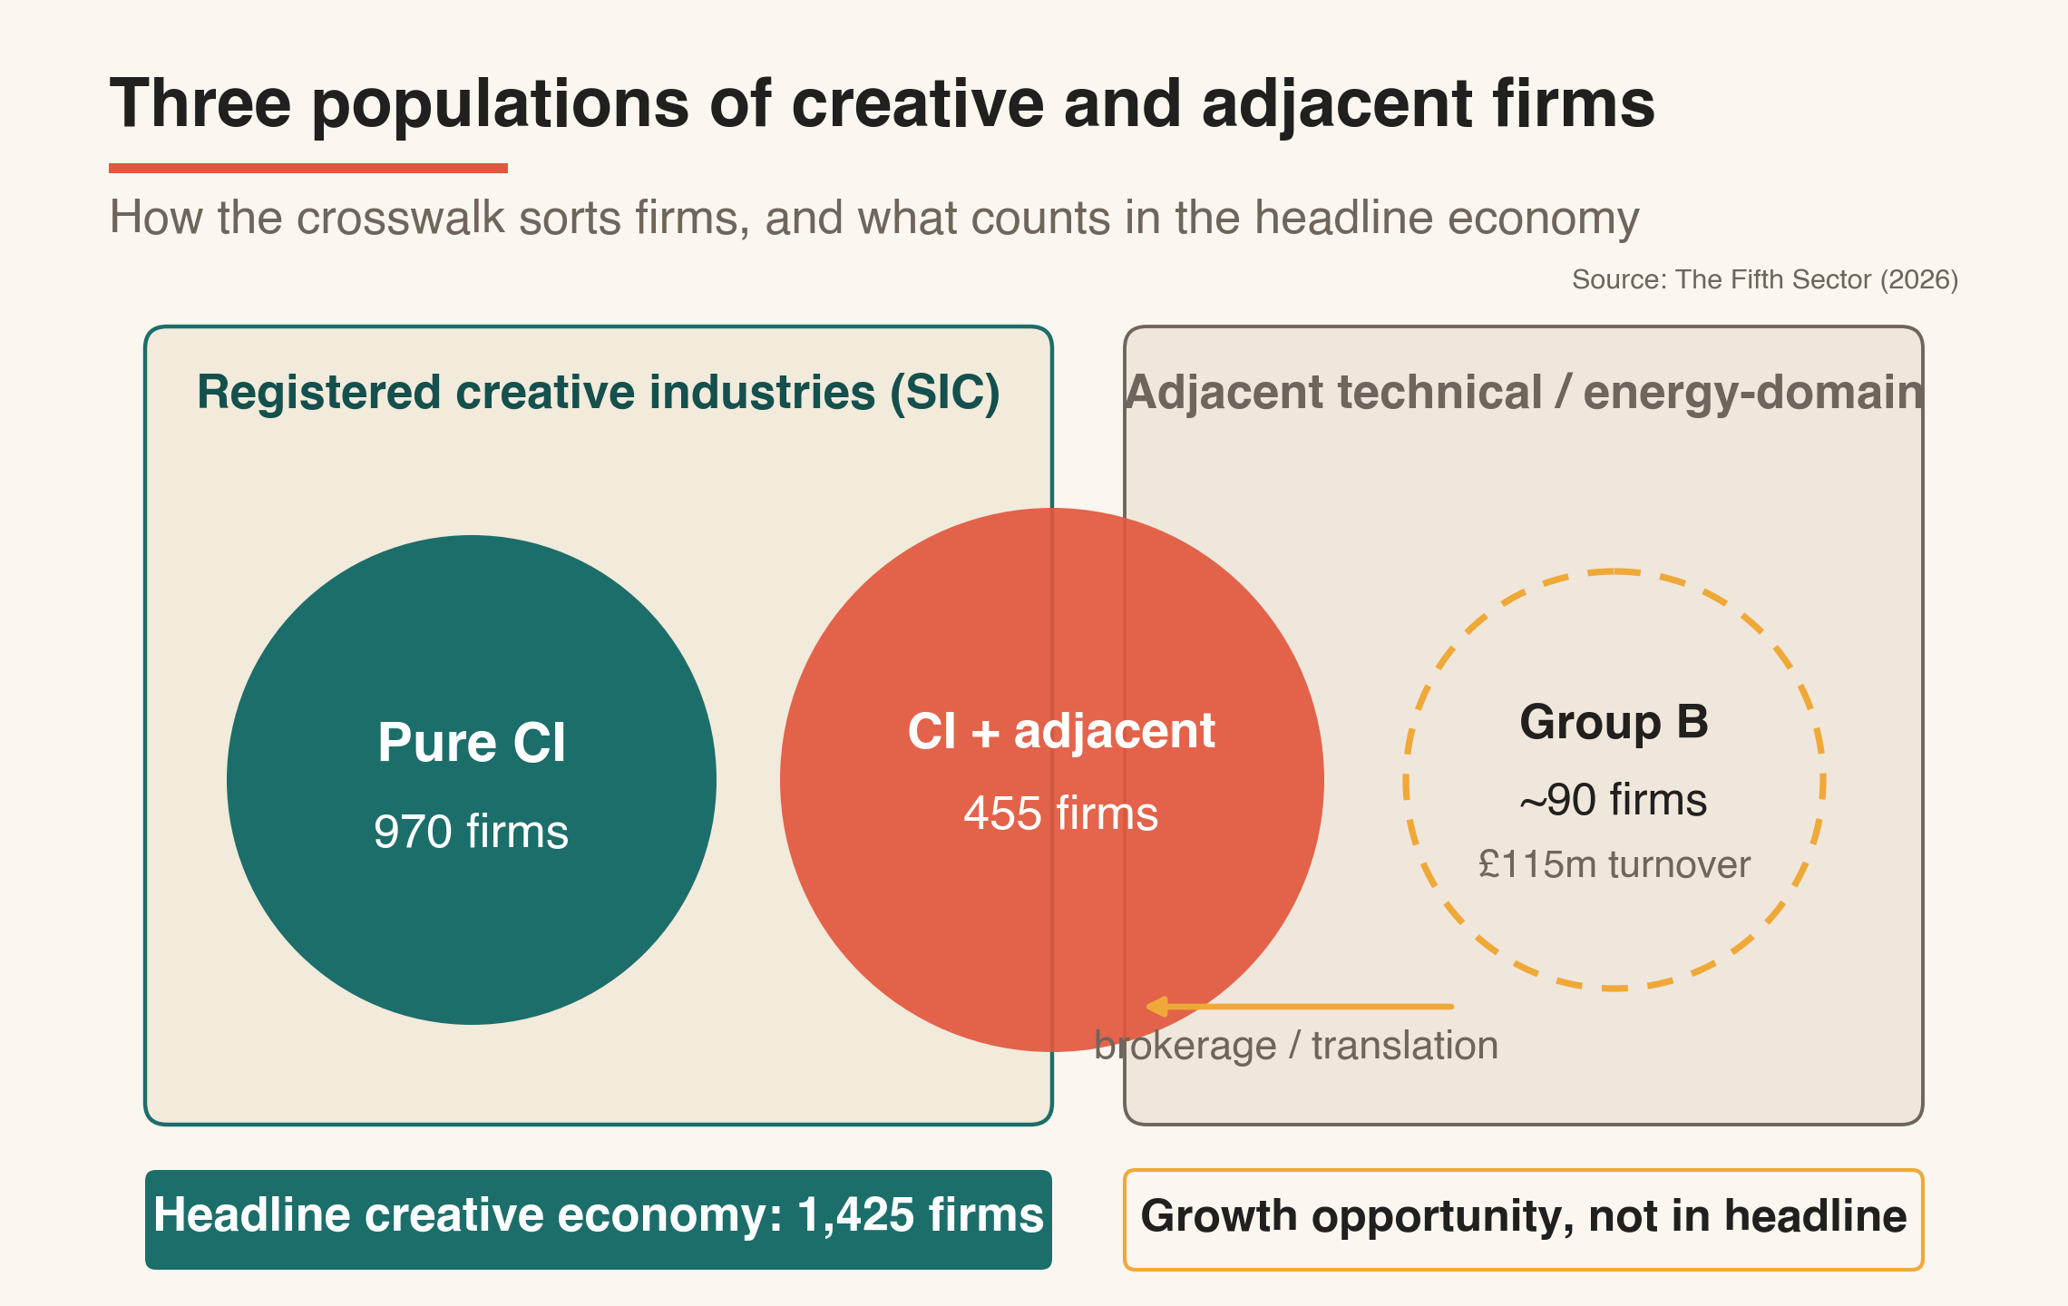

2.4 Three layers of evidence
BRES forms the floor: reliably counted, analytically secure, but blind to the freelance majority. LinkedIn supplies a missing layer of the professional creative workforce. It is a self-reported source that skews toward professional, digitally active workers, so it is treated as a large pre-filled occupational survey, with corrections set out in Appendix A.4, rather than as a complete register. On that basis it identifies more than 8,400 unique creative profiles among North East Scotland residents, including 1,500 full- and part-time employees and 3,280 freelance and self-employed workers absent from BRES (Table 3). The Data City supplies the third layer, comparing how firms register with what their websites show them doing, which corrects both dormant registrations and misclassification (Figure 3; Appendix A).
This combination also settles the double-counting question raised by the overlap of SIC codes counted within both creative and digital sectors. The crosswalk identifies the creative-digital subset using evidence-based rules and excludes general IT consultancy and the wider digital activity already mapped in the Opportunity North East Digital report. It also helps us recognise patterns which identify the simulation crossover with energy; but that employment and output are not counted toward the creative economy.

Figure 3: Three-layer evidence method
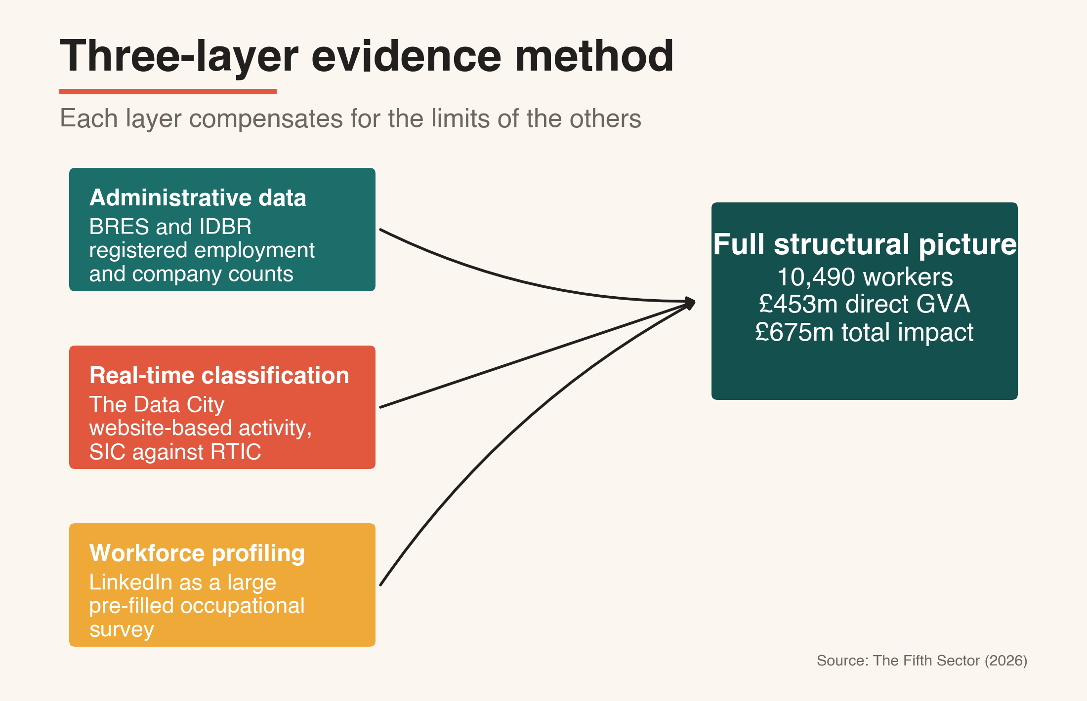
Table 3: Hidden workforce evidenced by LinkedIn, September 2025
Category | Count | Share
Total workforce | 8,455 | 100%
Full-time employees | 3,735 | 44%
Part-time employees | 1,140 | 13%
Employees subtotal | 4,875 | 58%
Contractor | 925 | 11%
Internship | 485 | 6%
Self-employed | 365 | 4%
Freelance | 1,505 | 17%
Freelance and self-employed subtotal | 3,280 | 39%

Source: The Fifth Sector (2026) / Unscrambled.world analysis of LinkedIn.

Part Three: A creative economy in four tiers
In brief
- Question: How is the economy structured, and what is it worth?
- What the evidence revealed: Four tiers, 10,490 workers, £453 million in direct GVA and £675 million in total economic impact. Tier 2 is the economic core; Tiers 3 and 4 are invisible to official data yet materially productive.
- How we addressed it: The tier model becomes the measurement spine (Recommendation 5) and the frame for the strategies in Part Nine.

The economy resolves into four tiers, each defined by its relationship to official statistics and its function in the wider system (Figure 4; Table 4).
Tier 1, institutional anchors: 65 publicly funded museums, libraries and performing arts venues, 1,210 workers, providing the public programming, skills pipeline and continuity the commercial tiers depend on (BRES; Creative Scotland funding records). Tier 2, commercial core: 920 registered creative and creative-digital firms, 3,845 workers, holding the client relationships, software, design and production capability that give the sector economic weight, and £226 million in direct GVA (BRES and The Data City). Tier 3, visible freelancers: 3,400 self-employed and contract practitioners identified through LinkedIn, the flexible capacity on which the commercial core draws. Tier 4, invisible workforce: an estimated 2,035 artists, makers and musicians, inferred from evidence of membership organisations, artists studios, participation in 'open studios' and penetration-gap analysis, carrying the region's cultural distinctiveness (Appendix A.6)
Table 4: Four-tier creative economy, scale
Tier | Registered  businesses | Headcount | FTE  intensity | FTE
Tier 1: institutional anchors | 65 | 1,210 | 0.71 | 860
Tier 2: SME commercial core | 920 | 3,845 | 0.90 | 3,445
Tier 3: visible freelancers | – | 3,400 | 0.75 | 2,550
Tier 4: invisible workforce | – | 2,035 | 0.42 | 860
Total | 985 | 10,490 | 0.74 (MEAN) | 7,715
Source: The Fifth Sector (2026). Rounded to nearest 5.

Together the four tiers generate £453 million in direct gross value added and £675 million in total economic impact, applying Scottish Government Type II multipliers (Table 5). Tier 2 produces most of the impact at £362 million, reflecting deeper local supply chains; a multiplier of 1.60 means every £1 of direct GVA generates a further £0.60 in the regional economy. The output of Tiers 3 and 4 comes from a practitioner base that BRES records as zero. The Tier 4 figure of £28 million is estimated using penetration analysis and validated in workshops (Appendix A.6 and A.8). The scale justifies treating the creative economy, including the artists dispersed across rural and coastal Aberdeenshire, as economic infrastructure. These totals combine measured and modelled components. Tier 1 and Tier 2 rest on BRES and registered-firm data; Tier 3 on LinkedIn profiling; Tier 4 on penetration-gap estimation. The Tier 3 and 4 figures of £28 million are therefore best estimates, and the £675 million headline should be read as a best-estimate aggregate rather than a precise count (full method and ranges at Appendix A).
Table 5: Gross value added and total economic impact, 2025

Tier | Headcount | FTE | Direct GVA (£m) | Type II multiplier | Total impact (£m)
Tier 1: institutional anchors | 1,210 | 860 | 25 | 1.40 | 35
Tier 2: SME commercial core | 3,845 | 3,445 | 226 | 1.60 | 362
Tier 3: visible freelancers | 3,400 | 2,550 | 174 | 1.40 | 244
Tier 4: invisible workforce | 2,035 | 860 | 28 | 1.20 | 34
Total | 10,490 | 7,715 | 453 | 1.51 avg | 675
Source: The Fifth Sector (2026). Multipliers reflect supply-chain depth (Tier 2 highest) and a conservative 1.20 for Tier 4. Rounded to nearest £1 million; columns may not sum from rounded values.

Figure 4: Four-tier creative economy
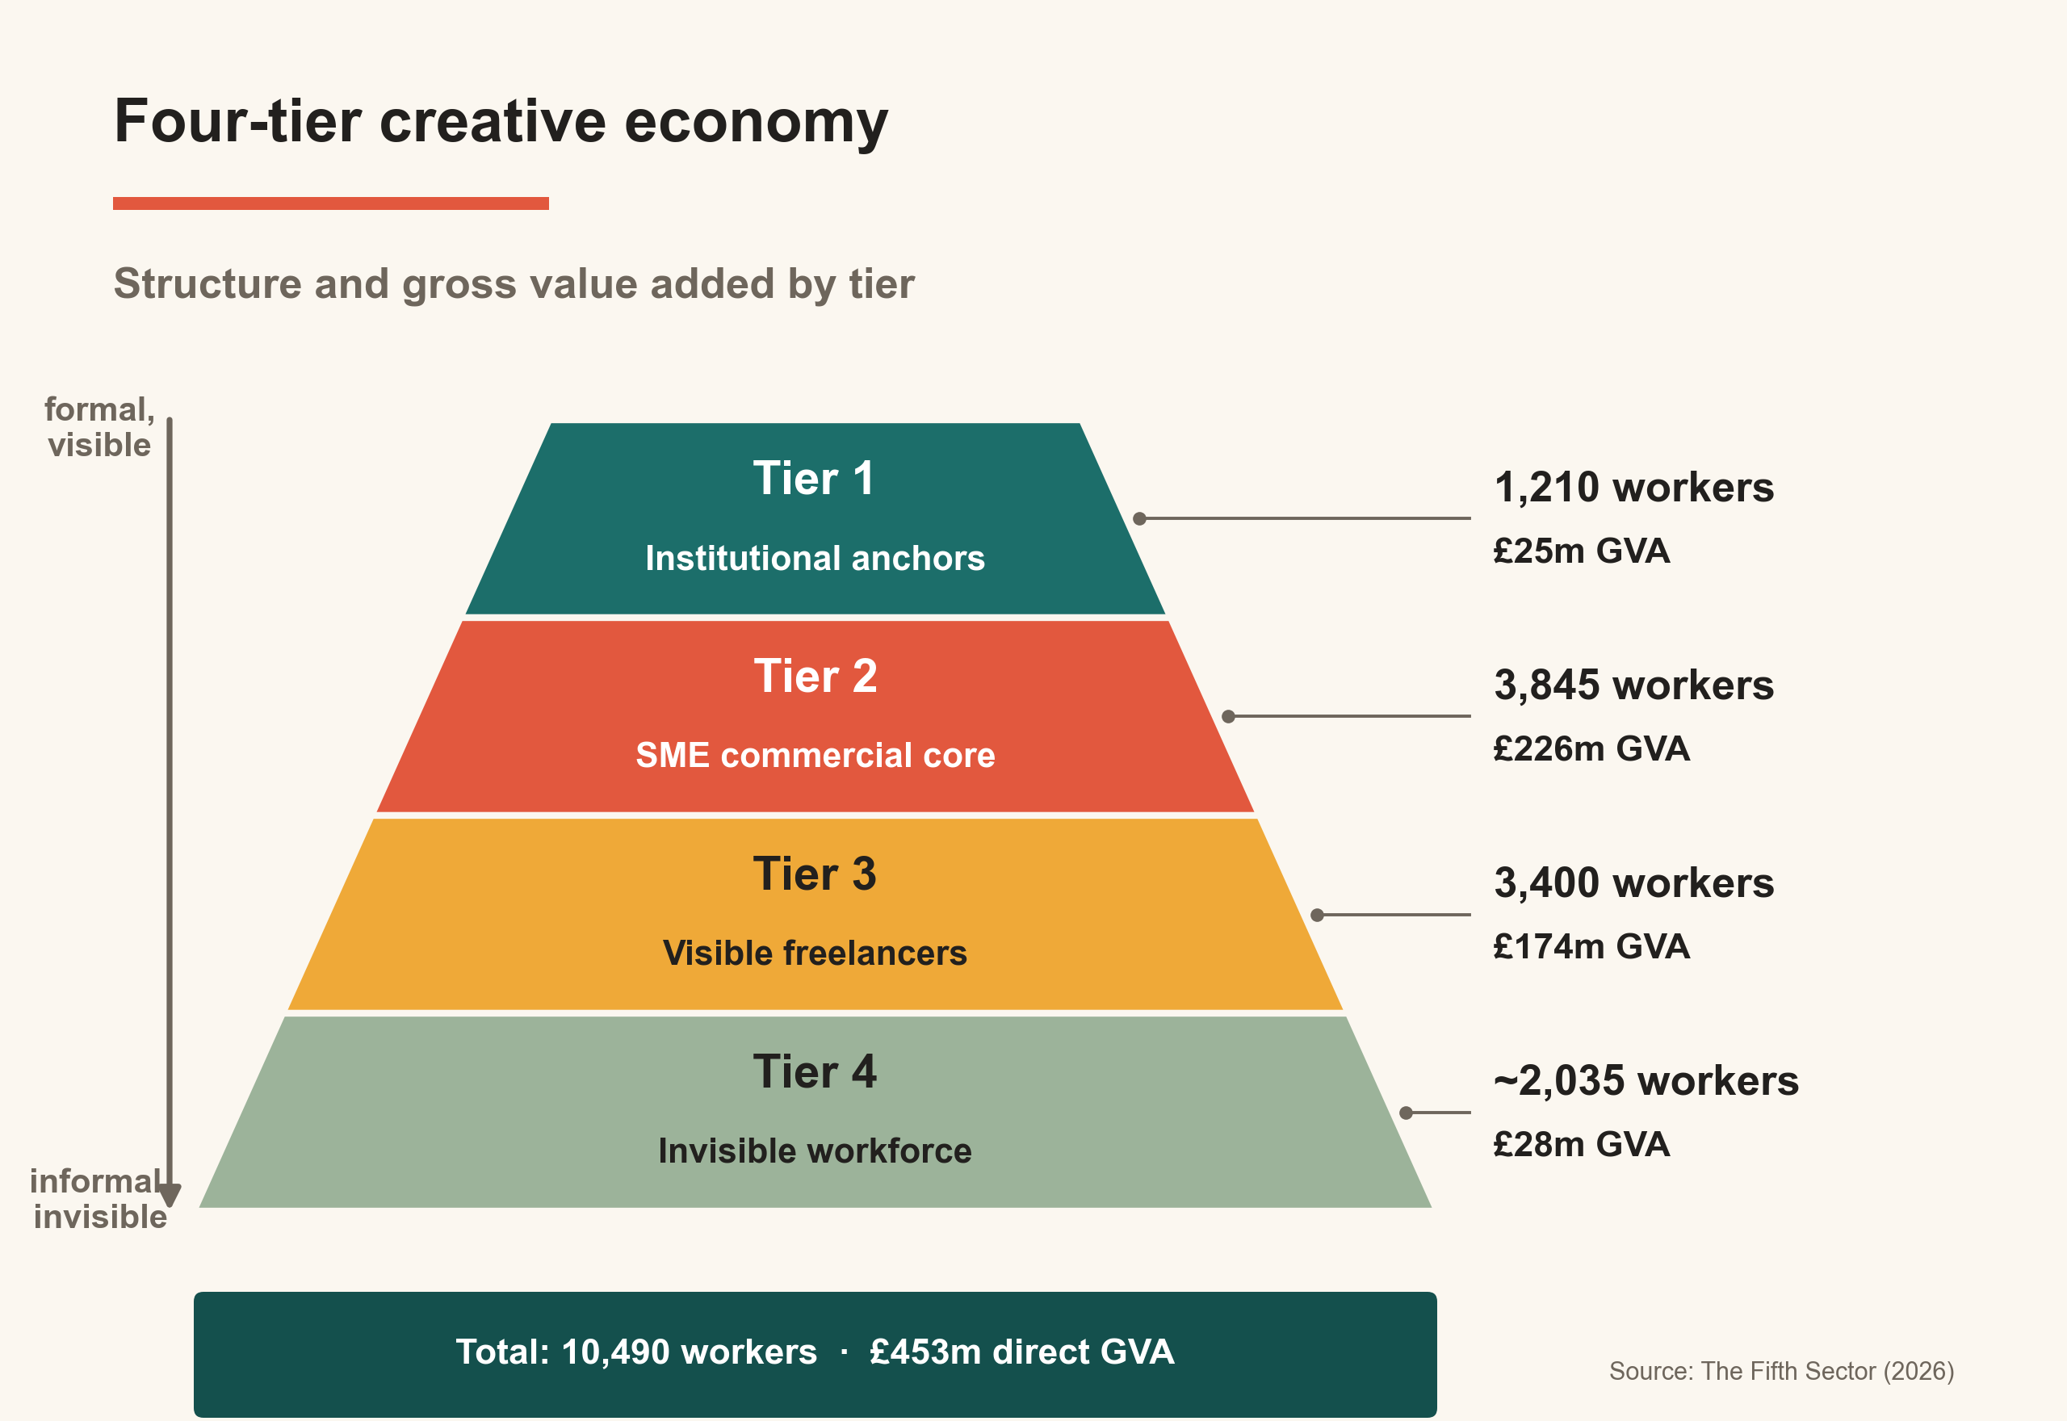

Part Four: The convergence opportunity
In brief
- Question: What is the region's distinctive growth opportunity, and what stands in its way?
- What the evidence revealed: Registered creative firms (Group A) and energy-domain technical firms (Group B) hold complementary capabilities, often within the same streets, yet have no working relationship.
- How we addressed it: Strategy 1 connects them through a named network and shared training; Recommendations 1 and 3 fund the infrastructure that builds convergence and test the market.

4.1 A dispersed economy, not a cluster
Measured by the standard cluster model, which assumes a dense concentration of creative firms generating agglomeration benefits (PEC, Newcastle University, 2023), North East Scotland does not form a single, dense creative cluster. Its registered creative firms concentrate in central Aberdeen, while the wider creative economy, cultural practitioners and adjacent technical capability alike, is spread the length of the region, from the north-east coast through the city to the rural hinterland. Three distinct groupings stand out instead, each with cluster-like potential.
The first is a city-centre creative core: around 45% of all registered creative firms in Aberdeen and Aberdeenshire sit in the AB10, AB11, AB15 and AB24 postcodes.
The second is a rural and coastal cultural base, spanning the region from Ballater to Fraserburgh, mostly individual artists and makers working outside registered business structures.
The third is an adjacent technical capability, spread across four geographic concentrations: the city centre, the Westhill-to-Dyce corridor, south Aberdeen and Stonehaven, and Inverurie and Kintore. Across these clusters, 90 firms (Group B) hold simulation, three-dimensional visualisation, digital-twin and geospatial capability built for the energy sector and transferable to creative markets, together recording £115 million in measured turnover and around 1,760 employees. That figure is the scale of adjacent capacity that could be drawn into creative markets, not a claim of current creative output: almost all of it is energy and engineering work today. (Appendix A.9).

4.2 Group A and Group B: complementary by capability
Two populations carry the convergence opportunity; we classify them as Group A and Group B.
Group A is the registered creative economy: the firms counted in Tiers 1 and 2 across the DCMS creative sub-sectors - architecture, advertising and marketing, design, film, video and screen, software and applications. Two counts describe it, measuring different things: the IDBR crosswalk identifies 1,425 firms holding creative-industries SIC codes (Table 2), while the workforce model counts 985 active businesses with staff, of which 920 form the Tier 2 commercial core (Table 4); in the firm classification of Figure 2, Group A is the "pure" CI and "CI plus adjacent" populations. These firms hold creative strategy, client relationships, design and content production, and in the larger agencies, established energy-sector accounts. What they mostly lack is engineering-grade simulation and the energy-domain knowledge needed to produce technically credible immersive assets, data visualisations and digital twins.
Group B is the adjacent technical population introduced in section 4.1: the 90 firms across the four clusters that sit outside the creative SIC codes but hold capability relevant to creative markets, built over decades of safety-critical offshore work: simulation, three-dimensional visualisation, digital twins and immersive training. Their £115 million of measured turnover and some 1,760 employees record current economic weight that is almost entirely energy and engineering work, with no current creative output; the convergence opportunity is to draw a share of that capacity into creative markets, with the firms already carrying core creative-technical classifications, around 25 showing evidenced crossover, as the readiest entry point. What these firms lack is the narrative, production and client-facing layer that would carry their capability into content, communications and public-engagement markets. The scale of the addressable creative market is to be validated under Recommendations 1 and 3 before investment is committed.
The two profiles are complementary, and the skills evidence quantifies the gap. Measured against the Nottingham comparator (Table 8, Part Five), the region's energy-technical workforce holds a simulation surplus of 3.5 times, while its creative sector shows deficits of 7.2 times in virtual production and 5.2 times in data storytelling - the bridging skills that would join technical depth to content markets. Each group holds what the other needs, and the markets that reward the combination, including energy-transition communication, immersive industrial training and digital twins for public engagement, require both capability sets in a single commission.

4.3 Spatially close, institutionally separate
The barrier is institutional, not geographic. The Westhill-to-Dyce corridor lies about ten miles from the city-centre agencies, inside the same travel-to-work area and the same city-region economy, so distance is not what keeps the two apart. Proximity has not produced connection.
Group A and B firms hold no shared identity, no collective voice, and no relationship with the region's creative-sector organisations or its support infrastructure. The most direct indication is an absence: no 'digital' (Group B) firm attended any of the four research workshops held as part of this research, despite direct outreach. Non-attendance has more than one possible cause and corroborates rather than proves the point. Taken with the agencies' own accounts, though, it is hard to read another way: city-centre creative agencies, asked about the simulation and visualisation firms on their doorstep, were largely unaware of them. The gap is institutional, a product of sectoral self-identification and the lack of any mechanism for exchange, and it is precisely the gap that further rounds of CoSTAR funding and the Creative Industries Cluster Programme are designed to close.

4.4 Four convergence points
Four points show where the two capability sets meet. Landscape and site-specific practice maps onto the statutory community engagement that major energy infrastructure must fund, anchored by Scottish Sculpture Workshop's Creative Climate Futures strand. Craft practice meets digital fabrication, where silversmithing and textiles traditions cross with the precision CNC, laser cutting and additive manufacturing already standard in regional engineering. Immersive performance meets industrial simulation, since both run on the same game engines, primarily Unreal Engine and Unity. Spatial audio and other sound technologies meet environmental communication, building on Sound Festival's record of place-rooted work on landscape change. Some crossover already happens inside the registered economy; the rest needs brokerage before it becomes investable.
In North East Scotland, createch means translating existing creative-digital, film, software, design and architecture capability into real-time screen, games, live performance and immersive markets, using the region's engineering visualisation and energy-domain simulation base as the differentiator. The strengths are already counted: 920 Tier 2 firms, 3,845 workers, £226 million in Tier 2 GVA, and around 2,300 simulation-skilled practitioners. This is the case a CoSTAR bid can credibly make, resting on documented capability rather than aspiration.

4.5 Market context
The market context is large and growing. UK creative industries generated £145.8 billion in 2024, 5.5% of UK GVA, growing 4.6% against 1.0% for the wider economy, with IT and software the largest and fastest-growing component (DCMS, 2026). Energy transition adds demand: offshore wind, hydrogen and grid projects carry statutory community engagement requirements, and the immersive and simulation markets are projected to grow quickly (Table 6).
Figures from commercial market aggregators are indicative rather than precise. Verified Market Research, IMARC Group and Mordor Intelligence are known to produce optimistic estimates, so the projections in Table 6 establish order of magnitude only. Primary demand research with regional energy buyers, statutory consultees and infrastructure developers is a year-one deliverable under Recommendation 3, before the full market development programme is committed.

Table 6: Market context for the convergence opportunity
Market | Current value | Projected value | Year | CAGR | Source
UK creative industries GVA | £145.8 billion | – | 2024 | 4.6% (2023-24) | DCMS (2024)
UK wind power | $39.3 billion | $95.3 billion | 2032 | 11.7% | Verified Market Research (2024)
Offshore wind capacity (UK) | 16.50 GW | 42.50 GW | 2030 | – | Mordor Intelligence (2025)
UK immersive technology | $1,348.2 million | $7,949.3 million | 2033 | 21.79% | IMARC Group (2024)
Global virtual training and simulation | $9.63 billion | $20.5 billion | 2035 | – | Industry Today (2024)

Source: The Fifth Sector (2026); Verified Market Research; Mordor; IMARC; Industry Today.

Part Five: Skills supply and capability
In brief
- Question: Does the region have the skills to exploit current markets and future opportunities, and does it keep them?
- What the evidence revealed: A 3.5 times simulation surplus sits alongside deficits in the bridging skills that reach creative markets, and the graduates who hold both creative and bridging skills leave.
- How we addressed it: Strategy 3 reframes the graduate skills pipeline and Strategy 1 adds two-way CPD, enabled by Recommendations 1, 3 and 5.

5.1 The pipeline
University of Aberdeen and Robert Gordon University (RGU) together enrol 3,675 students in creative and digital subjects, weighted toward computing and IT (RGU 2,800; Aberdeen 875; HESA 2023/24; Appendix B). RGU's BSc Computing and Creative Design and BSc Games Design build creative-technical hybrids and connect to articulation pathways from NESCol. The volume in design and media disciplines, around 1,370 combined, is enough to support a viable creative economy. The question is whether the local economy offers visible entry-level work that gives graduates a reason to stay.

5.2 Destination analysis
The answer is, 'not yet'. Of 1,527 mapped creative graduates from the two universities working in the UK, 46% remain in North East Scotland; measured across all international destinations retention falls to 32%, with RGU at 36% and the University of Aberdeen at 23% (LinkedIn; Table 7). Leavers go mainly to the Central Belt, where a larger creative economy and more visible entry-level roles provide the pull; University of Aberdeen creative graduates are now more likely to work in Glasgow or Edinburgh than in the region. The pattern is structural, examined further at section 8.1.

Table 7: Geographic destination of creative alumni
Institution | NE Scotland | Central Belt | London | International
RGU and Gray's School of Art | 530 | 442 | 102 | 395
University of Aberdeen | 179 | 193 | 81 | 316

Source: The Fifth Sector (2026) / Unscrambled.world LinkedIn and SOC analysis.

5.3 What the region holds and what it lacks
The skills data tells a structural story. Nottingham was chosen as a 'counterfactual' that reflected comparable population and distance from markets. Against that comparator, normalised to population size and agreed with the client in November 2025, North East Scotland holds a cohort of around 2,300 simulation practitioners, a surplus of 3.5 times (Table 8; Figure 5). The same offshore origin produced surpluses in production management (3.2 times), visual effects (3.1 times) and procedural workflows (2.4 times). These are the disciplines that deliver immersive training, animation and large-scale visualisation, and they are the depth that Group B firms hold.
The deficits are the mirror image. Virtual production skills run at a 7.2 times deficit to the Nottingham counterfactual, data storytelling at 5.2 times, technical AI at 4.7 times and real-time rendering at 4.1 times. These bridging skills connect technical depth to content markets, and they are the skills a creative education pipeline produces. The region produces them and then loses them: the graduates who hold them are the ones leaving for Glasgow, Edinburgh and London. A third gap sits outside the data, in business, enterprise and freelance skills, which Skills Development Scotland and the PEC both identify as a structural absence in the national curriculum (Appendix B).

Table 8: Skills position relative to Nottingham comparator
Skill area | NES vs Nottingham | Origin | Strategic implication
Simulation | 3.5x surplus (c.2,300 vs c.1,063) | 50 years offshore safety-critical training | Primary differentiator; CoSTAR anchor
Production management | 3.2x surplus (c.3,528 vs c.1,792) | Offshore project delivery | Enables large-scale delivery
VFX | 3.1x surplus (c.869 vs c.456) | Energy-sector visualisation | Bridge skill for screen and visualisation
Procedural workflows | 2.4x surplus (c.535 vs c.365) | Industrial process automation | Bridge for immersive and animation
Virtual production | 7.2x deficit (c.25 vs c.290) | Graduate outmigration | Priority curriculum target
Data storytelling | 5.2x deficit (c.377 vs c.3,175) | Graduate outmigration | Required for SME value-chain progression
Technical AI and data analysis | 4.7x deficit (c.329 vs c.2,500) | Pipeline misalignment | Required for creative-market access
Real-time rendering | 4.1x deficit (c.351 vs c.2,320) | No regional virtual production hub | Required for screen and immersive growth
Business and freelance skills | Structural curriculum gap | SDS and PEC | Required for freelancers to scale

Source: The Fifth Sector (2026) / Unscrambled.world. NES base 219,256 profiles; Nottingham 357,597. Per-capita ratios normalised against profile base.

Figure 5: Skills mirror, North East Scotland against Nottingham
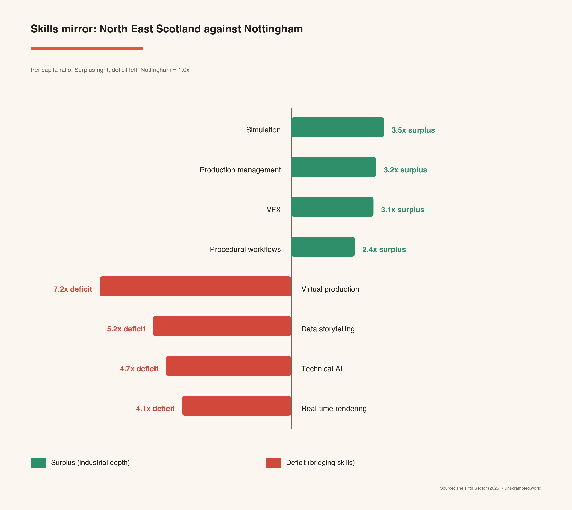

5.4 What it means for strategy
The simulation surplus is a prime competitive asset for North East Scotland, built by industrial investment rather than creative-economy spending, but it lacks the narrative and production layer that would carry it into content and communications markets. That layer exists in the region, across city-centre agencies, the graduate pipeline and the Tier 4 community, and it is not connected to the simulation depth. The virtual production and data storytelling deficits are addressable through curriculum, placement pathways and CPD (Appendix B), with the opportunity to secure UKRI investment in CoSTAR and the development of an Aberdeen-Dundee createch corridor as the mechanism. Retention follows opportunity: graduates stay when three pathways are visible, namely growth in the creative core, applied work in energy transition, and wider createch roles.

5.5 A London reference point
This report benchmarks counts of key creative skills against a Nottingham counterfactual. A like-for-like London comparison was not run, because the markets are too dissimilar in their scale and behaviour, and the report does not claim any direct comparisons. However, a parallel study of East London's creative experience economy carried out by The Fifth Sector (London Legacy Development Corporation, June 2026, unpublished) offers a structural London comparator, produced with the same methods used here. The point to weigh is its signal strength: the comparison rests on the parts of that study that are stronger signals, and it is read as triangulation rather than as a measured London ratio. Its provenance and the strength of each claim are set out at Appendix E.

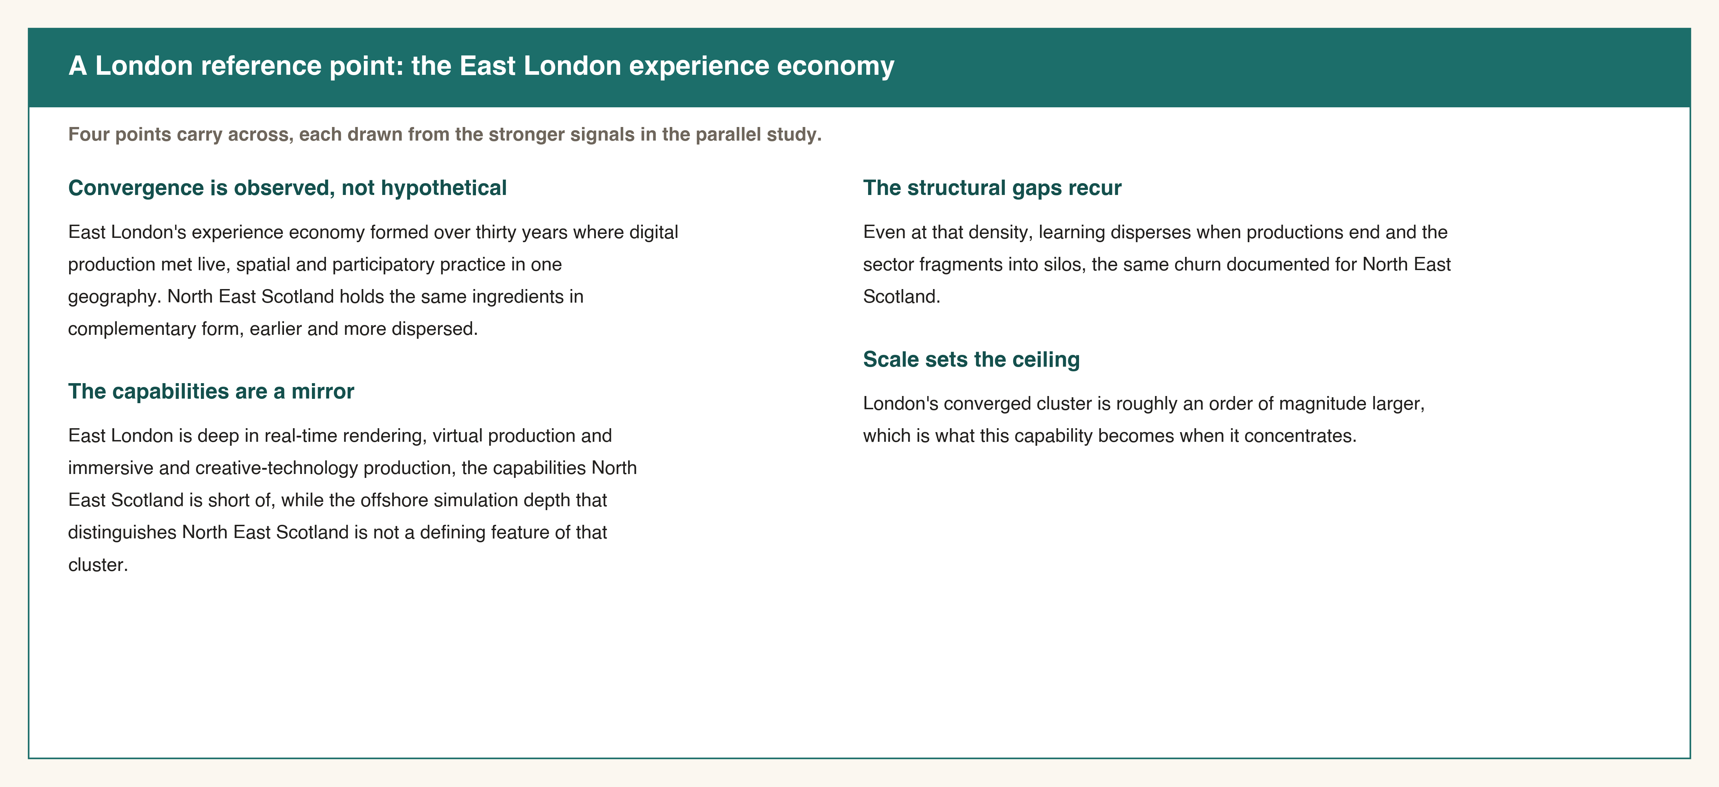

Convergence is observed, not hypothetical. East London's experience economy formed over thirty years where digital production met live, spatial and participatory practice in one geography. North East Scotland holds the same ingredients in complementary form, earlier and more dispersed.
The capabilities are a mirror. East London is deep in real-time rendering, virtual production and immersive and creative-technology production, the capabilities North East Scotland is short of, while the offshore simulation depth that distinguishes North East Scotland is not a defining feature of that cluster (Table 11).
The structural gaps recur. Even at that density, learning disperses when productions end and the sector fragments into silos, the same churn documented for North East Scotland in section 8.2.
Scale sets the ceiling. London's converged cluster is roughly an order of magnitude larger (Table 11), which is what this capability becomes when it concentrates.
The comparison is structural rather than quantified, and the source is an unpublished report from the same Fifth Sector team that produced this analysis, that has not been independently verified. It is offered as a signal-strength reference point, not as a structured counterfactual, and it carries weight only to the strength of the signals it rests on, which are stated explicitly at Appendix E.

Table 9: Capability mirror, North East Scotland and East London
 | North East Scotland | East London experience economy
Defining strength | Industrial simulation, 3D visualisation, energy-domain knowledge (offshore) | Real-time rendering, virtual production, immersive and creative-technology production; live, spatial, participatory practice
Relative gap | Virtual production, real-time rendering, data storytelling, immersive production | Industrial and energy-domain simulation depth
Scale | 1,425 firms; 10,490 workers; £453m GVA | ~2,100 companies; ~27,000 workers; £3bn+ GVA
Stage of formation | Dispersed, pre-cluster | Mature, converged cluster (~30 years)
Comparator basis | Nottingham per-capita benchmark (Table 8) | Structural, drawn from CELL (June 2026, unpublished)

Source: The Fifth Sector (2026) research commissioned by London Legacy Development Corporation, Loughborough University and UCL, June 2026 (unpublished). Signal strength and provenance at Appendix E.

Part Six: Aligning data and primary research
In brief
- Question: Do practitioners recognise the patterns the data shows?
- What the evidence revealed: Interviews and four workshops confirmed each major desk finding, finding by finding, and surfaced a clear divergence in what different parts of the sector need.
- How we addressed it: Triangulation raises confidence in the strategies and shapes the split between Regional Economic Strategy and Local Outcomes Improvement Plan responses.

Qualitative and quantitative work was designed to test the same questions from two directions. Interviews with stakeholders across policy, education, cultural and creative organisations ran from October 2025 to April 2026, and four in-person workshops in Aberdeen in November 2025 brought together practitioners, anchor organisations, council officers and national agencies. Where the desk research and the consultation agree, the finding is stated with more confidence; where they diverge, the divergence is itself a finding.
Five desk findings were confirmed in consultation.
The asymmetry of skills distribution (section 5.3) appeared directly in the room. Tier 2 firms described being treated as transactional suppliers: a participant in aa workshop focused on advertising and marketing agencies confirmed that in work with energy sector clients, "the relationship stops at 'deliver the brief' rather than co-creating value", the commercial signature of a missing data-storytelling and strategy layer. The software and simulation firms that hold the complementary depth did not attend any of the four workshops, despite repeated outreach, and city-centre agencies described little awareness of the simulation and visualisation firms nearby. The separation between Group A and B firms implied in the firm data was made visible by the workshops.
Freelance precarity and the retention failure (sections 5.2 and 8.1) were stated plainly. Practitioners called the sector "hidden, hungry, struggling and undervalued", and screen practitioners noted that "finding experienced freelance crew locally is hard; people either move away for work or burn out". Both statements reflect the 32% creative retention rate and the thin commercial middle the data records.
Organisational churn (section 8.2) was described from inside the cultural sector. Cultural practitioners pointed to "fragile" spaces run by volunteers and to funding systems where "as soon as the grant ends the whole thing collapses".
The narrative brake (Strategy 4) drew agreement across every tier. "The loudest story about Aberdeen is still that it's an oil town past its peak", and practitioners across screen, design and marketing want to take ownership of the transition story rather than leave it to corporate communications.
The consultation also surfaced a divergence that shapes the response. Commercial creative firms rarely ask for subsidy; their frustration is regulatory and reputational, that the "aspirational branding of the city" does not match the experience of doing business. Cultural practitioners ask for stability and infrastructure. This split reflects the distinction between economic and non-market cultural value described in Throsby and Bakhshi's framework, and it is why the commercial sector is addressed through Regional Economic Strategy market mechanisms while the cultural sector is addressed through Local Outcomes Improvement Plan investment in stability.

Part Seven: Cultural sector as economic infrastructure
In brief
- Question: Why does the cultural foundation matter, economically and socially, to the region's future?
- What the evidence revealed: Rural and coastal heritage gives the regional offer its distinctiveness; cultural life is a condition for retaining people; yet the sector is funded at only 44% of the Scottish average while carrying demographic weight in the transition.
- How we addressed it: Strategy 2 and Recommendation 4 secure the foundation; Recommendation 2 carries the funding case to Creative Scotland and the Scottish Government.

7.1 Rural and coastal cultural heritage as the source of distinctiveness
The four-tier model captures formal activity. It does not capture the cultural foundation on which that activity depends, and that foundation is what makes the regional offer distinctive rather than generic. North East Scotland holds four millennia of built and landscape heritage, a concentration of prehistoric monuments found in few other parts of Europe, and a living culture carried in the Doric language, the bothy ballad tradition and the Greig-Duncan folk song collection. Its craft traditions in silversmithing, textiles and applied arts are recognised internationally. This is the heritage that external markets read as authentically of the place, and it is the differentiator beneath the createch argument in Part Four: a generic technology cluster can be assembled anywhere, while an offer rooted in this culture cannot.
That foundation is carried by the Tier 4 practitioner base, some 2,000 artists, makers and musicians dispersed across rural and coastal Aberdeenshire. Their organisation is real even where it is invisible to official data. North East Open Studios has consistently engaged more than 300 artists and makers across the region, and provides the connective infrastructure between practitioners that Matarasso identified in 2014 as the distinguishing feature of the Aberdeenshire cultural sector. The relationship runs in concentric circles, from the registered and LinkedIn-visible base at the centre, through studio communities such as Deemouth Artist Studios and networks such as North East Open Studios, out to the dispersed individual practitioners at the edge (Appendix C). Only the innermost ring appears in any official count.

7.2 Two economic functions: retention and demographic infrastructure
The cultural foundation has two economic functions that the tier model does not price, and both matter directly to the just transition in whose name this report is commissioned.
The first is retention. Workshop evidence is explicit that cultural life is a condition for staying: "people are more likely to stay in Aberdeen if they see culture and creativity as part of everyday life, not just weekend entertainment", and "even if someone has a good job, if they don't see any cultural life that speaks to them, they'll eventually move somewhere that does". Matarasso's 2014 audit documented a pattern of established artists and makers moving to or returning to the area in mid-career, bringing networks and markets with them. We infer the same patterns in the 46% of mapped creative graduates now working in the region is consistent with that retention and return pattern continuing.
The second is demographic. The structural decline of North Sea oil and gas creates a population risk that reaches well beyond the creative workforce. Without the conditions that make a place worth living in, outflow spreads across community sections rather than occupational categories. A region that loses significant population at the point of economic transition risks decline rather than diversification. On that reading, cultural and heritage infrastructure is part of the demographic infrastructure of the transition, and underinvestment in it is a risk to the region's future workforce as a whole. This is the link between the funding gap in section 7.3, Strategy 2 and Recommendation 4, and the demographic dimension of the change the theory of change anticipates.
The visitor-economy benefits of the region's heritage and landscape are real and are evidenced by the scale of heritage tourism, but they are not measured by this research and are not claimed here. What is claimed is the institutional expression of the foundation: held and interpreted through the museums, libraries and heritage bodies of Tier 1, and carried as living practice by the Tier 4 makers. Neither role appears in firm counts or GVA, and neither can be rebuilt once lost.

7.3 Funding and structural strain
Regular arts funding from Creative Scotland for North East Scotland is only 44 per cent of the Scottish per-head average. Aberdeen City receives 66 per cent of that average; Aberdeenshire is much lower, at 27 per cent. Table 9 sets out the position. Neither the pattern nor the differential has changed significantly since 2014, when Matarasso attributed it partly to a culture of self-reliance and a distaste for the reporting that formal funding requires, with the result that real and sustained activity goes unsupported. No programme since has changed the underlying conditions. This is not only a sector funding gap but structural underfunding of transition infrastructure. The disparity between the two council areas is itself part of the governance case in Part Eight.
Cultural organisations that have grown since 2014 share one characteristic: multi-year structural funding, which carries a 34% first-year uplift rising to 54% in the current round. The connective organisations that perform freelance infrastructure, rural connectivity, audience development and sector intelligence hold no equivalent security. They range from unfunded communities of practice to project-funded networks, and that range is itself evidence of how unevenly essential functions are supported. The case study of Deemouth Artist Studios and Edit Aberdeen is a single example of what stable relationships can produce: a model that, with university support, provides a community studio in Torry with a city centre retail hub (the Bon Accord Centre). That connects Tier 4 practitioners to Tier 2 commercial pathways, with named makers trading internationally through the Goldsmiths Fair and US markets (Appendix C).

Table 10: Creative Scotland multi-year funding per head, 2025-28
Area | MYF  organisations | 3-year award (£) | Annual average (£) | Population (2022 Census) | Per head per  annum (£) | % of Scottish average
Aberdeen City | 10 | 5,814,449 | 1,938,150 | 228,670 | 8.48 | 66%
Aberdeenshire | 5 | 2,830,349 | 943,450 | 274,890 | 3.43 | 27%
North East Scotland | 15 | 8,644,798 | 2,881,599 | 503,560 | 5.72 | 44%
Scotland | 251 | 210,521,564 | 70,173,855 | 5,436,600 | 12.91 | 100%
Source: The Fifth Sector (2026) analysis of Creative Scotland Multi-Year Funding data (accessed 26 May 2026) and National Records of Scotland Census 2022. These figures cover Multi-Year Funding only; total Creative Scotland investment in the region will be higher. MYF is used as the comparator because it is the most directly comparable cross-authority dataset and because MYF status is the benchmark against which the structural fund argument in Recommendation 4 is framed.

7.4 City centre as cultural infrastructure
Cultural use also supports the city-centre retail environment. Aberdeen City Council's city centre manager confirmed in April 2026 that Bon Accord's pitch to incoming retail tenants references Edit and the Curated Market as differentiators (Appendix C.7), consistent with evidence that distinctive independent retailers generate positive agglomeration effects (Wrigley and Lowe, 2002). The Schoolhill stretch, with the city's worst vacancy rate, is the priority location for cultural activation. Connecting creative organisations to existing mechanisms, including the council's Fresh Start Relief 12-month business rates package for new occupants of vacant units, is achievable at no additional cost.

Part Eight: Structural challenges
In brief
- Question: What structural conditions block progress, and what must change first?
- What the evidence revealed: Graduates leave for want of mid-tier work; connective organisations collapse on removal of short-term funding; and no body holds the mandate to connect strategy and support across the two council areas.
- How we addressed it: Recommendation 2 establishes the governance precondition; Recommendation 4 stabilises the connective tier.

8.1 Graduate retention
Only 17% of all graduates from the region's universities remain in the region after study. For creative alumni the combined retention rate is 32%, with 46% of UK-based creative graduates in North East Scotland, RGU at 36% and the University of Aberdeen at 23% (Table 7). The local economy has not developed enough capacity to absorb the skills pipeline it produces. A graduate who understands both digital production tools and the energy-transition narrative is more valuable to a regional creative-digital firm, an adjacent simulation firm or a city-centre agency than to a generic London agency.
The Creative Career Bridge proposed in Strategy 3 makes that connection visible, subject to the demand testing in Recommendation 5.

8.2 Organisational churn
A creative economy of the scale of North East Scotland should generate lasting institutional infrastructure. Instead, it repeatedly builds it, and the networks and intermediaries repeatedly dissolve when project funding ends. This report names that pattern organisational churn (Figure 6). Connective organisations documented in the 2014 audit, delivering audience development, sector intelligence and creative-industries coordination, have since closed without successors. Each cycle of short-term funding loses years of accumulated relationships and practitioner knowledge that successor organisations cannot reclaim, eroding the institutional memory and cultural connectedness on which the wider economy depends. The difference between survival and collapse is a multi-year funding relationship: the 15 regional organisations in Creative Scotland's portfolio have grown, while the connective tier has not. The condition is documented across UK creative economies (PEC 2023); dispersal and the absence of sub-threshold structural funding make it harder to interrupt here.

Figure 6: Churn cycle
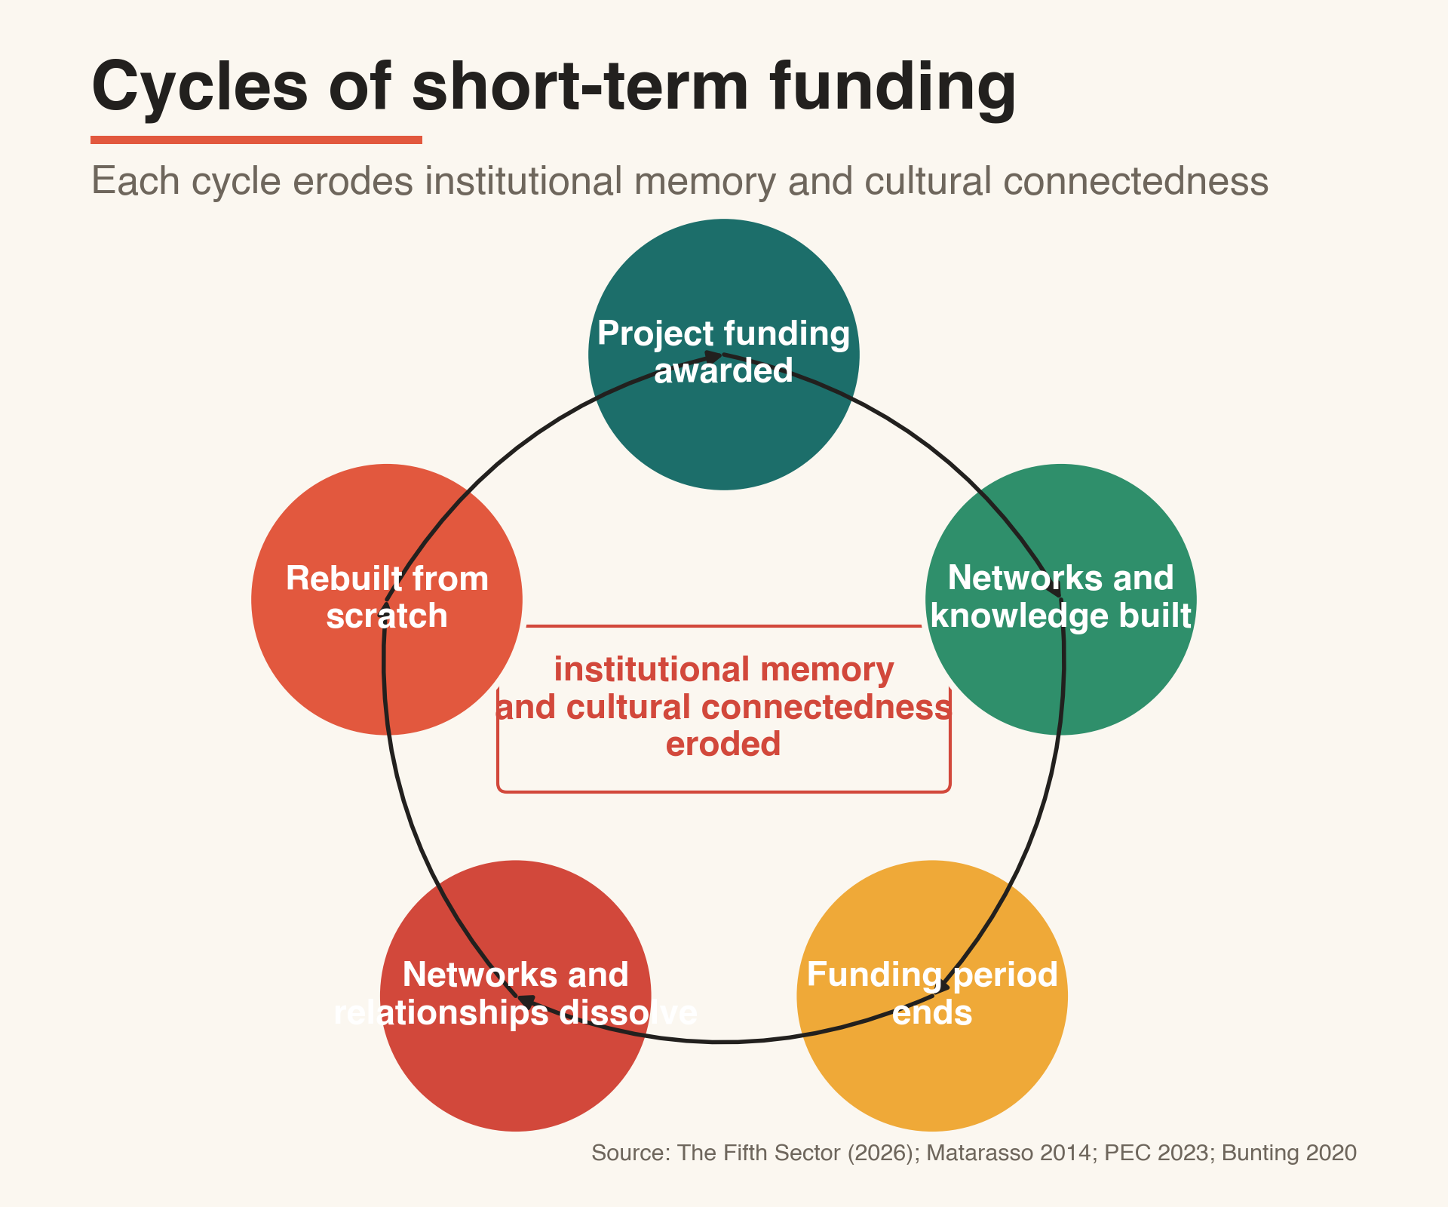

8.3 The City and Shire governance gap
The third structural challenge is governance, and it is the one that holds the others in place. The creative economy spans two local authorities with separate budgets, separate cultural funds and a dispersed geography that no single body coordinates. The consequences are visible in the evidence already presented. The funding disparity between the two areas, Aberdeen City at 66% of the Scottish average and Aberdeenshire at 27% (Table 9), reflects the absence of a shared strategy across the boundary. The churn cycle persists because no body holds a standing mandate to move strategically important organisations onto multi-year footing before they dissolve. The Group A and Group B disconnect persists because no body is configured to broker it. As consultation put it, the sector currently relies on individuals' goodwill and spare time to perform the coordination that other sectors receive dedicated resource to deliver. Previous reviews recommended that existing bodies align rather than create new structures; that instinct is reasonable and it has not resolved the problem, because none of the existing bodies holds the mandate, the resource or the cross-boundary authority to act as the sector's champion. This is the gap Recommendation 2 is designed to close, and the reason it is the precondition for three of the other four recommendations. The full options assessment behind the choice of a joint board is set out in Appendix D.

8.4 Live strategic opportunities
CoSTAR (Convergent screen technologies and performance in realtime) is Innovate UK's programme investing in creative technology research and development infrastructure. The AHRC Creative Industries Clusters programme funds university-led industry partnerships to promote creative R&D, including in frontier and adjacent sectors of the knowledge economy. North East Scotland is a credible applicant to both because its case rests on documented capability. Two funding rounds make up a single time-bounded opportunity. CoSTAR satellite funding confirmation is expected in June 2026, and the third round of the Creative Industries Cluster Programme (CICP3) is expected in 2027; an outline AHRC application is already in preparation by RGU and the University of Aberdeen. The £100 million UKRI investment in Creative Clusters, including a £27 million third-round opportunity expected to open in January 2027, is the most significant forthcoming route. The region needs to be positioned for both CoSTAR and CICP3, and that requirement sets the timetable for the Joint Board.
Regional screen models show what modest investment returns. The North East Screen Industries Partnership generated over £65 million in GVA, a 131% rise in production spend and 1,046 FTE jobs in three years, with 65% of crew drawn locally (North East Screen, 2025; employment figure attributed to Saffery-Nordicity). The Liverpool City Region Production Fund, a £2.8 million investment, returned £24.5 million and 861 indirect FTE jobs, around £8.75 per £1 of public investment (Liverpool Film Office, 2026), and has subsequently been recapitalised by the Combined Authorities from its own funds. A regional film office and production fund at comparable scale would address the virtual production deficit directly and build a reusable crew base.

Part Nine: Four growth strategies
In brief
- Question: What should be done, and how does each action trace to the evidence?
- What the evidence revealed: The four strategies map onto the four enabling conditions of the theory of change and onto specific findings in Parts Two to Eight.
- How we addressed it: Three strategic pathways were assessed; the convergence opportunity was selected as the lead, with two safeguards carried from the options set aside. Each strategy is delivered through named recommendations in Part Ten; Table 10 sets out the full evidence-to-action map, and the full options appraisal is at Appendix D.

The evidence in Parts Four to Eight admits more than one response. Three pathways were weighed against a do-minimum baseline: a city-centre creative cluster, durable in principle but capital-intensive and dependent on confirmed demand; a freelance-first strategy, equitable and low in cost but unable to raise the region's value ceiling or anchor national investment; and the convergence opportunity, which requires no first-phase capital, exploits the capability that most distinguishes this region, and preserves the cluster option for a later and better-evidenced decision. Convergence is the selected lead pathway. It carries forward two safeguards from the options set aside: institutional durability, designed to address the churn cycle the evidence documents; and distributional balance across the city and the wider area. The full options appraisal is set out in Appendix D.
Four strategies translate the evidence into action, each delivered through one or more of the recommendations in Part Ten (Figure 7). They are sequenced. Strategy 1 builds the commercial connections; Strategy 2 protects the cultural foundation those connections draw distinctiveness from; Strategy 3 addresses the graduate pipeline, which is solvable only once the economy is worth staying for; Strategy 4 is the narrative condition for all three. Structural funding alone would steady the cultural base but would leave the two halves of the commercial economy unconnected and the national research and development funding out of reach; that is why the programme pairs structural support with connectivity and the CoSTAR and CICP3 routes, a choice set out in full in the options assessment at Appendix D. Table 10 shows how each strategy and recommendation traces back to the evidence and forward to a policy frame.
Table 11: From evidence to action
Finding (evidence) | Strategy | Recommendation | Policy frame
Economy undercounted; Tier 4 invisible (Parts 2-3) | Measurement spine | R5 | RES and LOIP
Simulation surplus; Group A and B disconnect (Parts 4-5) | Strategy 1 | R1, R3 | RES
Bridging-skills deficit; graduate outflow (Parts 5, 8) | Strategy 3 | R3, R5 | RES and LOIP
Heritage distinctiveness; Tier 4 contribution (Part 7) | Strategy 2 | R4 | LOIP
Demographic risk in transition (Part 7) | Strategy 2 | R4 (advocacy via R2) | LOIP
Churn; City and Shire governance gap (Part 8) | Enabling condition | R2 | RES and LOIP
Narrative as economic brake (Parts 6, 9.4) | Strategy 4 | R2 | RES and LOIP
Underfunding at 44% of average (Part 7) | Strategy 2 | R4, advocacy via R2 | RES and LOIP
Source: The Fifth Sector (2026).

9.1 Strategy 1: Connect complementary capabilities commercially
The evidence base is the Group A and Group B mirror in Parts Four and Five: around 90 Group B firms, carrying some £115 million of transferable technical capacity, hold capabilities relevant to creative markets but cannot access creative-industries support because the route from technical capability to creative opportunity has not been made visible. The intervention has two interdependent components. A Creative-Digital Market Access and Connectivity Programme brings city-centre agencies and energy-domain firms into a named network and structures consortium bids, with a first-phase target of three joint commercial relationships and one demonstrator translating simulation into screen, games or live performance. A short-cycle CPD programme at RGU and NESCol runs in both directions: technical practitioners gain narrative and production skills, agencies gain energy-systems and simulation literacy. A network without the programme is a directory; the programme without the network disperses when the course ends. Together they form the commercial infrastructure the economy lacks, and they lay the track for an Aberdeen-Dundee Creative Technology Corridor with CoSTAR and Abertay. Low capital cost, high strategic return.
Addresses: Tiers 2 and 3, and adjacent Group B firms. Regional Economic Strategy. Delivered through Recommendations 1 and 3.

9.2 Strategy 2: Protect and develop the cultural sector
The evidence base is Part Seven: a Tier 4 population of around 2,035 practitioners generating an estimated £28 million from a base recorded as zero, carrying the heritage that makes the regional offer distinctive, and functioning as demographic infrastructure for the transition. Practitioners ask for recognition rather than subsidy. Four actions sit within existing frameworks at low or zero cost: connect community interest companies operating as creative market infrastructure to existing rates relief consistently; record the Gray's School of Art and Edit graduate retention pathway in RGU and regional skills reporting; extend connectivity, peer networks and mobile support to rural Aberdeenshire, with Schoolhill the priority urban location; and pilot a Creative Wellbeing Economy programme as preventive health infrastructure, generating LOIP wellbeing data that does not yet exist. The demographic argument in section 7.2 is the reason this strategy belongs in the transition agenda and not only in cultural policy.
Addresses: Tiers 1 and 4. Local Outcomes Improvement Plan. Delivered through Recommendation 4.

9.3 Strategy 3: Reframe the graduate pipeline as a transition asset
The evidence base is Parts Five and Eight: RGU retains 36% of mapped creative alumni and the University of Aberdeen 23%, because the economy has not generated enough mid-tier employment to give graduates a reason to stay. Three pathways change that: progression in the creative core, applied work in renewables and energy transition, and createch roles in screen, games and immersive content. A Creative Career Bridge, a twelve-month paid placement funded by Scottish Enterprise, the RES and employer contribution, places graduates with creative firms, adjacent firms entering creative markets, cultural anchors and agencies building energy-transition offers. A parallel pilot maps mid-career energy workers facing redundancy into creative practice, connecting the RES transition agenda to the LOIP economic participation outcome.
Addresses: Tiers 3 and 2. RES and LOIP. Delivered through Recommendations 3 and 5.

9.4 Strategy 4: Tell a different story
The evidence base is the narrative brake confirmed across every tier in Part Six. The scale and capability in this report do not feature in how the region presents itself to investors, graduates or its own practitioners. Three evidenced claims are offered for the Joint Board to test and deploy: the simulation surplus, measured against the Nottingham benchmark, is an asset the region can credibly position as nationally significant; the Edit model shows, in a single documented case, that the invisible economy can generate measurable value when given minimum institutional conditions, with documented retail income from a population BRES records as zero (single-source case study, Appendix C.5); and the energy transition is the region's distinctive creative offer, combining industrial simulation, energy-domain knowledge and rural-coastal identity. A formal NES Creative Economy Narrative, maintained by the Joint Board, is the frame within which the other strategies operate.
Addresses: All tiers. RES and LOIP. Delivered through Recommendation 2 (the Joint Board).

Part Ten: Five strategic recommendations
In brief
- Question: What decisions make the strategies operational, and in what order?
- What the evidence revealed: The recommendations form a dependency graph, with the Joint Board as the precondition for three of the others, against a June 2026 deadline.
- How we addressed it: Each recommendation is costed, assigned and sequenced; Table 10 ties each to its evidence and strategy.

Each recommendation is the governance or investment decision that makes one or more strategies operational (Figure 7).

Recommendation 1: Advance a joint CoSTAR bid (RES)
Both councils, both universities and Scottish Enterprise formalise as co-applicants to the UKRI Creative Clusters bid, framed as a createch translation model, ahead of the June 2026 confirmation. The evidential base combines 920 Tier 2 firms and £226 million in Tier 2 GVA with the adjacent depth in Group B: 90 firms across four clusters carrying around £115 million of measured turnover and some 1,760 employees, whose simulation and visualisation capability is transferable to creative markets. CoSTAR and Creative Industries Cluster Programme funding support research, development and market-access infrastructure rather than production subsidy, and the demand validation in Recommendation 3 gates the full connectivity and market-development programme, so the bid and the validation run in parallel. Active now; full application to follow June 2026.

Recommendation 2: Establish a joint cultural and creative economy board (RES and LOIP)
This is the response to the governance gap in section 8.3. A shared budget line, dedicated officer resource and a formal mandate over measurement, structural funding, the bid and national advocacy give the region a single body able to act across the boundary. The existing Creative Industries Working Group is the foundation; it needs decision-making authority and capacity. Comparable bodies in Glasgow City Region, Yorkshire and the West Midlands suggest a minimum of one full-time equivalent and a programme budget of £50,000 to £100,000 a year. Year 1.

Recommendation 3: Align the creative economy with energy transition (RES and LOIP)
Place creative-technology skills within the energy transition skills strategy and pair creative organisations with the community engagement and environmental communication the transition requires. Year-one demand validation with energy buyers and statutory consultees precedes the full programme, since the convergence case is currently supply-led. Indicative cost £200,000 to £400,000 over three years, including £30,000 to £50,000 for validation. Years 1 to 4.

Recommendation 4: Stabilise connective infrastructure (LOIP)
Establish a Creative Ecology Structural Fund (LOIP). A jointly governed structural fund, supported by Creative Scotland and Scottish Enterprise, provides three-year revenue funding to four to six strategically critical organisations against published criteria, with a pathway to Creative Scotland multi-year status as the exit condition. This is the direct answer to the churn cycle in section 8.2 and the underfunding in section 7.3. Indicative cost £150,000 to £300,000 a year. Years 1 to 2.

Recommendation 5: Commit to full-spectrum measurement (RES and LOIP)
A shared framework covering all four tiers, tracking economic, social and cultural value in line with section 1.3, updated every three years, through the proposed NES Culture Data Hub jointly governed by both councils. The first-year programme tests whether the markets served by narrative firms and by simulation firms overlap, which determines the strength of the case for Strategy 1 and Recommendation 3. Indicative cost £100,000. Year 1.

Sequencing
The recommendations form a dependency graph. Recommendation 2, the Joint Board, is the precondition for Recommendations 3 and 4 and the full delivery of 5 (Figure 7). Recommendation 1 and the first phase of Recommendation 5 can begin without it. The CoSTAR and CICP3 rounds in 2026 and 2027 are the time-bounded opportunity the programme is built around. The nearer boundary is June 2026: the Joint Board must be advanced enough by then to appear as a co-signatory on the CoSTAR bid, and in place to position the region for CICP3. A single governance decision therefore unlocks most of the programme.

Figure 7: Recommendation dependency and sequencing
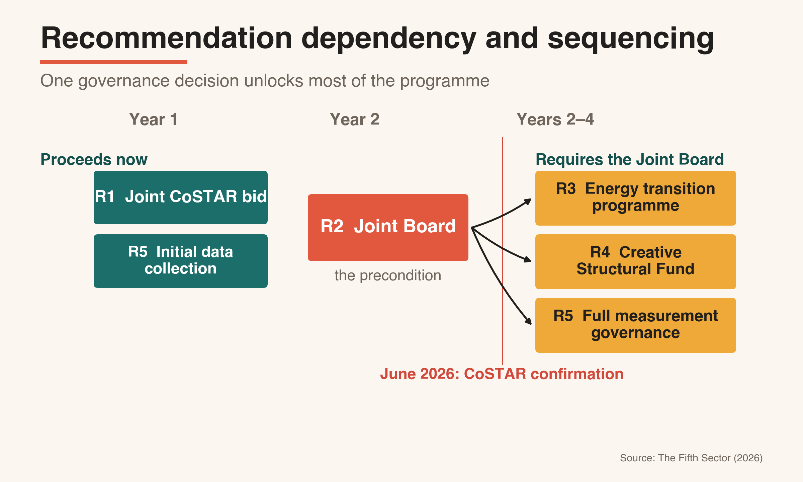

Conclusion

The contribution of this report is measurement. The four-tier model and the RTIC-based crosswalk reveal a creative economy larger, more technically capable and more economically significant than earlier accounts recorded, and they show how its parts relate. Our research includes the cultural population identified by Matarasso in 2014, when he warned that it was at risk of invisibility. It is still in place, now quantified, and now attached to an asset his lens could not have seen: a registered creative economy with energy-domain depth, and adjacent technical firms whose simulation capability has a route into creative markets. The same culture that makes the region worth measuring also makes it worth living in, which is why the cultural, social and economic cases are one case. The analysis locates a connection waiting to be made. Making it is a question of governance, sequence and timing.
The detailed evidence, methodology and data tables supporting this report are set out in Appendices A to D, with comparative London evidence in Appendix E and a consolidated list of references in Appendix F. The policy playbook and the ITQ Action Plan compliance matrix are provided as separate documents.

Appendices

Appendix A: Methodology

A.1 Purpose and structure of this appendix
This appendix sets out the complete methodological basis for the workforce estimates, gross value added calculations, skills analysis and economic impact figures presented in this report. It is structured to allow independent scrutiny and replication of each analytical step.
The research was conducted between September 2025 and April 2026. The workforce model, GVA estimates and skills analysis draw on data collected and validated during that period. Where figures in earlier working documents differ from those presented here, the figures in this report are authoritative. Two corrections to earlier drafts are documented explicitly at A.4 and A.8.
The methodology combines three distinct analytical approaches: official administrative data (BRES and IDBR), real-time firmographic and workforce data (The Data City platform and LinkedIn), and qualitative primary research (stakeholder workshops and practitioner interviews). Each approach has different strengths, limitations and appropriate uses; the combination is designed so that the limitations of each are addressed by the strengths of the others.

A.2 Establishing the business base: the crosswalk methodology

A.2.1 The gross registration universe
The starting point for the business base analysis is a dataset provided by The Data City platform, representing businesses registered in the Aberdeen and Aberdeenshire area under creative or technology-adjacent Standard Industrial Classification (SIC) codes. The Data City uses artificial intelligence to analyse company website content combined with Companies House registration data, financial filings and other public sources, assigning each firm a Real-Time Industrial Classification (RTIC) that reflects its actual trading activity rather than its registered SIC code. SIC codes are assigned at point of registration and rarely updated; a firm registered in 2005 under SIC 62020 (IT consultancy) may have moved into games development or immersive content production in the intervening years without updating its registration. The RTIC system addresses this by updating classification continuously on the basis of current website content.
Both The Data City platform and the Inter-Departmental Business Register (IDBR) capture only firms with a formal legal structure. Self-employed sole traders and working proprietors without a registered company do not appear in either source. The business counts in this analysis represent the registered business base only; the self-employed and unregistered workforce is captured separately through the LinkedIn analysis and penetration gap modelling described at A.5 and A.6.

A.2.2 The crosswalk filter
To move from gross registrations to a verified creative business base, this analysis applies a crosswalk methodology that assesses each firm against a single defining criterion: does the firm derive value primarily from original intellectual property and cultural curation, rather than from the provision of labour hours or technical infrastructure services?
The filter was applied in two passes. The first pass removed clearly excludable firms on the basis of four evidenced grounds: brass plate registrations using corporate hub addresses with no independent evidence of physical operations (60% of the firms at corporate hub addresses were confirmed as noise through spot checks of 425 registrations); personal service companies established as tax-efficient vehicles for individual IT contractors in the energy sector (40% of technology-adjacent SIC registrations followed this pattern); nominee registrations with no local staff, office footprint or evidence of trading activity (25% of the excluded population); and industrial utility firms whose primary output is technical infrastructure support for the energy sector -asset integrity management, reservoir telemetry, technical safety documentation -rather than creative content, products or experiences. The second pass involved spot-checking, contractor pattern analysis and physical footprint verification.
Application of the crosswalk filter identifies 1,380 registered businesses with one or more Creative Industries SIC codes. These comprise 924 pure Creative Industries firms and 456 firms that combine Creative Industries SIC codes with adjacent non-CI activity, rounded in Table 2 to 925 and 455 respectively. The subsector allocation in Table 2 uses each company's primary Creative Industries SIC code to avoid double-counting firms with multiple CI SICs. Museums, galleries and libraries are then adjusted to the IDBR count because Companies House and The Data City undercount public-sector cultural institutions that do not always appear as separately incorporated companies. This adds 45 to the pure CI column, producing the report's ordinal business-count total of 970 pure CI firms, 455 CI+adjacent firms and 1,425 combined CI-coded firms. These museums, galleries and libraries are counted in Tier 1 institutional anchors, not in the Tier 2 SME commercial core; Tier 2 therefore excludes the 50 museums, galleries and libraries institutions shown in Table 2. A further pure adjacent population is treated separately as a potential growth opportunity rather than as part of the headline creative economy.

A.2.3 SIC 62020 and the digital crosswalk
SIC 62020 (IT consultancy) is the most common SIC code in the registered creative-digital firm population of North East Scotland. The crosswalk applies a two-stage treatment rather than a blanket exclusion.
Stage one identifies firms that are excluded because no creative-digital evidence exists. These include businesses providing generic IT infrastructure support, staff augmentation and system integration services to the energy sector, personal service contractor vehicles and dormant registrations. Of the 435 firms registered under SIC 62020 in IDBR, around 305 fall into this category and are excluded. Their employment - the 1,600 workers and estimated £150 million in GVA attributed to SIC 62020 in the BRES data - is not counted in the creative economy figures. Readers comparing these figures with national estimates that include all IT consultancy within the creative industries definition may add £150 million to the direct GVA figure and £228 million to the total economic impact figure.
Stage two identifies firms that are retained because there is positive evidence of creative-digital trading activity. Two sub-groups qualify: firms carrying SIC 62020 alongside at least one other creative industries SIC code, and firms registered solely under SIC 62020 but carrying an explicit Real-Time Industrial Classification confirming current creative-digital trading such as software product development, data infrastructure services, AI applications or immersive technology. Together these two sub-groups account for around 215 firms retained in the creative-digital business base that underpins Tier 2.
The remaining pure SIC 62020 firms without RTIC confirmation were reviewed as a precautionary population. Firms with no confirmed creative-digital trading evidence are excluded from the creative economy counts so that the creative economy is not inflated by energy-sector enterprise support, system integration and personal service contractor vehicles. This treatment retains creative-digital SIC 62020 firms where evidence supports creative relevance, while excluding generic IT consultancy activity.
This also provides the evidential basis for the report's double-counting safeguard with the ONE Digital Tech Sector Insights report. The ONE report, using the Company Connecting taxonomy, separately identifies 309 regional technology companies, including EnergyTech, Other Tech, IT and IT & Engineering firms. The present report does not reclassify that wider digital technology base as creative economy activity. It retains only the creative-digital subset evidenced through SIC combinations, RTIC classification and manual review.
The IT Services and Consultancy population identified through LinkedIn analysis - 3,992 individuals across IT Services (1,710) and IT Consulting (2,282) - was held in a separate segment of the LinkedIn dataset throughout the analysis and was not included in the creative workforce count at any stage. The significance of this separation is documented at A.4.

A.2.4 The convergence tier
Beyond the registered CI-coded company population, The Data City analysis identifies a convergence tier of firms in the energy services and engineering sectors that have developed, over decades of safety-critical offshore operations, a technical capability in simulation, three-dimensional visualisation, digital twin development and immersive training that is directly contiguous with the capability base of the creative technology sector. Under standard SIC classification these firms do not appear in creative industries counts, but real-time industrial classification and human validation confirm their creative-technical hybrid character.
The convergence tier spans four geographic concentrations (city centre; Westhill-Dyce corridor; south Aberdeen and Stonehaven; Inverurie and Kintore). Across them, 90 adjacent firms (Group B) hold transferable energy-technical capability and record £115.2 million in measured turnover and 1,762 registered employees, with no current creative-industries output; this is the scale of adjacent capacity, not a measure of creative GVA. Within that population, 24 firms carry explicit core creative-technical classifications and around 25 show evidenced creative-technical crossover today, the readiest point of entry. The four-cluster breakdown and source are at A.9. This represents potential growth opportunity rather than current contribution to the creative economy headline figures; its strategic significance is addressed in the recommendations rather than in the headline economic totals.

A.3 Official employment baseline: BRES
The Business Register and Employment Survey provides the administrative floor of the analysis. BRES data for Aberdeen City and Aberdeenshire, filtered against creative industries SIC codes and adjusted to remove generic IT consultancy activity without creative-digital evidence, produces a count of 3,305 employees. This figure represents the minimum that can be confirmed from official data: it captures the region's publicly funded cultural institutions, its registered design and architecture practices, and its commercial creative firms, but misses the self-employed, freelance and portfolio workforce entirely.
BRES data is the primary source for Tier 1 (institutional anchors) and provides the employed workforce baseline for Tier 2 (SME commercial core). BRES headcount figures are cross-validated against The Data City company intelligence and adjusted to include directors of registered micro-companies who are remunerated via dividends rather than salary and therefore do not appear in BRES employment counts. These dividend-remunerated directors are identified through cross-referencing of Companies House officer records against The Data City company profiles; their inclusion in the formal workforce count is methodologically appropriate as they are directors of registered limited companies, not unregistered sole traders.

A.4 LinkedIn workforce analysis

A.4.1 Methodology
LinkedIn data was used to identify the creative workforce population beyond the formal BRES-captured employed base. The platform was treated as a large pre-filled occupational survey rather than a social media tool: profile data was extracted for residents of the North East Scotland geography with occupations in creative sector classifications, structured into six creative supply chain segments and one separate IT Services and Consultancy segment.
The six creative supply chain segments are: Content (film, television, video, music, broadcast media, photography), Experiences (performing arts, museums, heritage, dance), Originals (visual arts, fashion design, craft, independent artists and writers), Services (advertising, marketing, PR, architecture, design), Tech (creative technology including software development and computer games), and a Total Creative Supply Chains summary sheet. The IT Services and Consultancy segment -covering IT Services (1,710 individuals) and IT Consulting (2,282 individuals), total 3,992 -was maintained as a separate, parallel dataset throughout the analysis and was not included in the creative workforce count. It was captured for reference purposes only, to allow comparison with the excluded BRES IT consultancy population.

A.4.2 Correction of a double-subtraction error in earlier drafts
Earlier working documents in this project applied a subtraction of the IT Services and Consultancy population (3,992) from the Total Creative Supply Chains figure (9,414), producing a net figure of 5,422. This was an error. The 3,992 IT Services and Consultancy workers were never included in the 9,414 Total Creative Supply Chains figure; they were held in a separate segment throughout. Subtracting them from 9,414 therefore removed a population that had not been added, reducing the creative workforce count by 3,992 people who should have been included.
The correct total from the LinkedIn creative supply chain analysis, incorporating all six creative segments, is 9,414. This figure is then adjusted as described at A.4.3 to produce the working creative workforce total of 8,760.
All workforce, FTE, GVA and economic impact figures in this report reflect the corrected analysis. The figures 5,422, 7,530, £315 million and £474 million appearing in earlier working documents should be disregarded. The authoritative figures are those in Part Three of this report.

A.4.3 Software development and computer games
The Tech segment of the LinkedIn creative supply chain data includes 1,957 individuals identifying as working in software development and 179 in computer games, alongside 275 in computer and network security, 599 in information services, and 83 in other technology classifications (desktop computing software products, IT system custom software development, digital accessibility services, social networking platforms).
Software developers and games developers working in creative technology contexts are creative economy workers; their inclusion is consistent with the DCMS creative industries framework, which includes IT, software and computer services within the creative industries taxonomy. However, the computer and network security and information services populations within the Tech segment were omitted from our workforce calculations: they are more likely to come under other Digital SIC codes and to have been included in estimates of employment for the ONE Digital sector report. This is a methodological boundary case that is acknowledged as such; their combined headcount of 874 represents 10% of the creative Tech segment and a smaller share of the total workforce.
LinkedIn allows this analysis to observe a larger IT/software professional population than is visible in national sources. That may reflect the greater granularity of the LinkedIn dataset, or it may reflect the energy sector's demand for specific high-end digital capabilities. The analysis in Part Four suggests that both explanations may be true.

A.4.4 Adjustment for museums and libraries underrepresentation
Comparison of the LinkedIn-derived Experiences segment (591 individuals, of whom 136 are attributed to museums and galleries) against the BRES count for museums, galleries and libraries (435 employees) reveals significant underrepresentation of this workforce in LinkedIn data. This reflects the well-documented pattern of lower LinkedIn adoption among public sector cultural workers, part-time museum and library staff, and older workers in heritage roles.
To correct for this underrepresentation, the museums, galleries and libraries workforce is taken from BRES (435) rather than LinkedIn. Historical sites workers (185, from the LinkedIn Experiences segment keyword count) are added to this population as they represent the same institutional type and are included in our analysis of Tier 1 organisations. The combined museums, galleries, libraries and historical sites workforce is 620, of which 620 are attributed to Tier 1.
The resulting adjusted LinkedIn total of 8,760 (replacing 9,414) is the basis for the tier allocations in Table 12 below.

A.5 The four-tier workforce model
The LinkedIn-adjusted total of 8,760 is allocated to tiers on the basis of employment status (employed versus self-employed/freelance/contractor) and sector, and supplemented by the Tier 4 penetration gap estimate. The resulting four-tier allocation is set out in Table 12.

Table 12: North East Scotland creative workforce by tier
Tier | Source and allocation basis | Headcount | FTE intensity | FTE
Tier 1: Institutional anchors | BRES, Creative Scotland funding records and institutional site validation | 1,210 | 0.71 | 860
Tier 2: SME commercial core | BRES and The Data City crosswalk, excluding generic IT consultancy activity without creative-digital evidence | 3,845 | 0.90 | 3,445
Tier 3: Visible freelancers | LinkedIn employment status, including freelance, self-employed, contractor and internship roles in creative supply-chain segments | 3,400 | 0.75 | 2,550
Tier 4: Invisible workforce | Penetration gap analysis, including core practitioners and shared utility workers | 2,035 | 0.42 | 860
Total strategic creative core |  | 10,490 | 0.74 (mean) | 7,715

Source: The Fifth Sector (2026). Headcount and FTE figures are rounded to the nearest five. FTE intensity values are rounded for presentation.

Figure 8: Crosswalk and pure adjacent identification

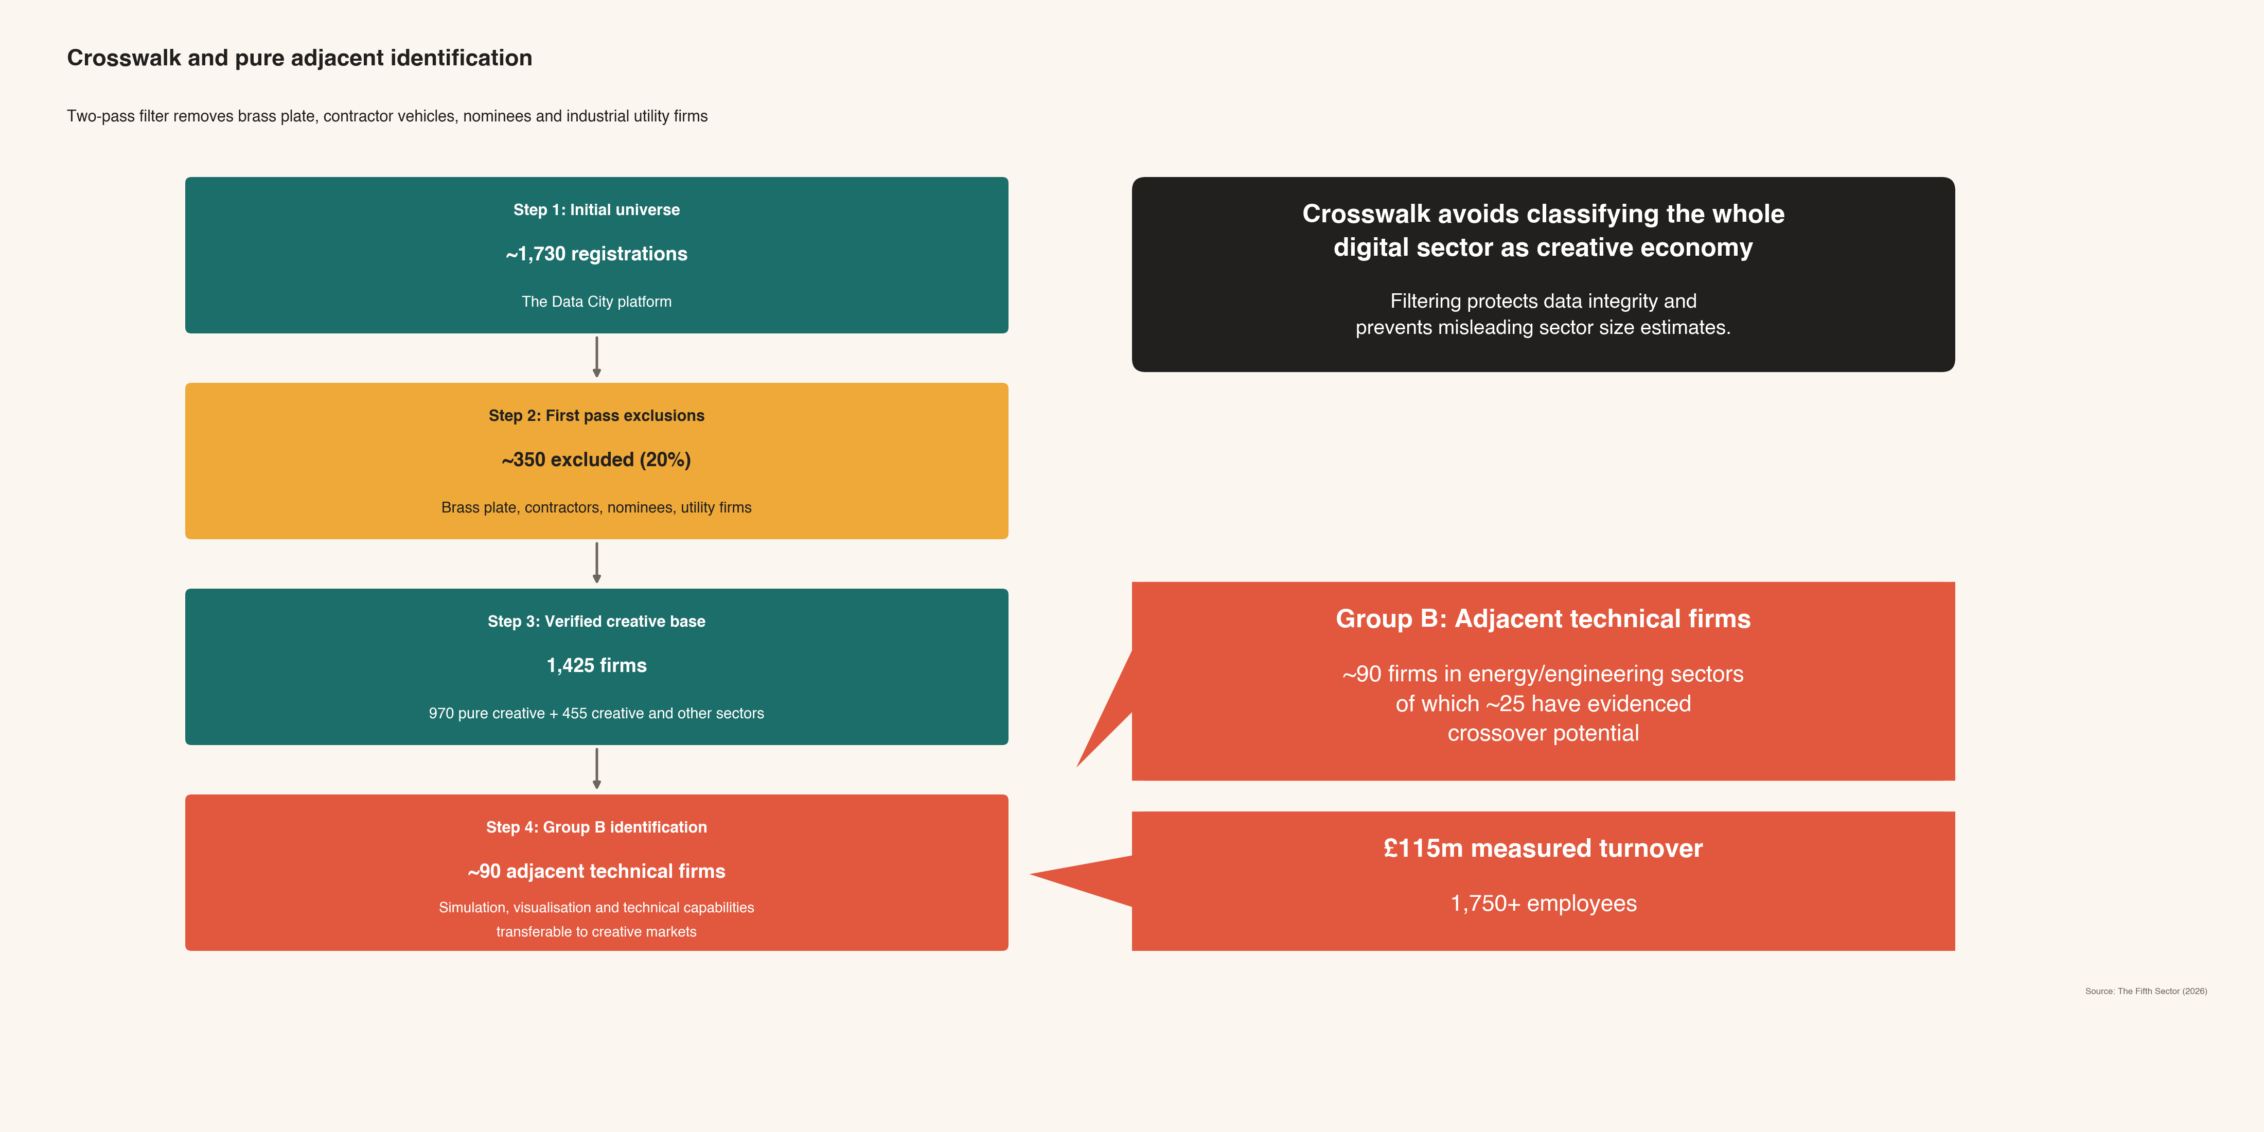

A.6 Tier 4: the invisible workforce
Tier 4 cannot be measured directly. It is estimated through penetration gap analysis: the difference between the estimated total population of creative practitioners in low-digital sub-sectors and the proportion identifiable through LinkedIn and official data. LinkedIn penetration rates for independent musicians, artists, writers and craft makers are estimated at 30% to 45%, against over 80% for technology and design professionals. The Tier 4 estimate of 1,855 core practitioners is derived from this gap, using workspace density modelling, open studio participation records (North East Open Studios network: 320-plus participants in 2013, Matarasso, 2014), trade body membership analysis, and comparative evidence from the Liverpool Music Futures cluster mapping study.
A further 180 shared utility workers in hospitality and events are attributed to the creative economy using the Liverpool Music Futures methodology, which allocates a fraction of hospitality and events employment to the live music and creative events economy. This population is attributed at 0.15 FTE intensity, reflecting that their creative economy contribution represents a small fraction of their total working time. This produces 27 FTE from 180 headcount.
The combined Tier 4 population is therefore 2,035 individuals (1,855 core practitioners plus 180 shared utility workers). The underlying calculation gives approximately 862 FTE before presentation rounding. For consistency with the authoritative tier controls used throughout the report, Tier 4 is presented as 860 FTE, with a blended FTE intensity of 0.42.
Note on earlier drafts: earlier working documents recorded Tier 4 headcount as 1,855 and FTE as 835, omitting the 180 shared utility workers from the table. The shared utility workers were always part of the methodology; their omission from the table was an error. All report-facing tables now use the corrected presentation total of 2,035 headcount and 860 FTE.

A.7 Full-time equivalent adjustment
Creative employment is characterised by high levels of part-time working, sessional contracts and portfolio careers. Each tier is adjusted by an FTE intensity factor converting headcount to full-time equivalent positions before GVA is calculated.
Table 13: FTE intensity factors by tier
Tier | Head-count | FTE intensity | FTE | Basis
Tier 1 | 1,210 | 0.71 | 860 | High part-time and sessional working in performing arts venues, museums and libraries; consistent with national BRES hours-worked data for the sector
Tier 2 | 3,845 | 0.90 | 3,445 | High full-time stability across architecture, design and creative technology; confirmed by BRES hours data and LinkedIn seniority profile (61% with ten or more years' experience)
Tier 3 | 3,400 | 0.75 | 2,550 | Project-based working with periods of inactivity between commissions; LinkedIn activity data and sector survey evidence
Tier 4 (core) | 1,855 | 0.45 | 835 | High proportion of part-time and non-commercial practice; studio occupancy and open studio participation data
Tier 4 (shared utility) | 180 | 0.15 | 25 | Partial attribution of hospitality and events staff to creative economy; Liverpool Music Futures methodology
Tier 4 combined | 2,035 | 0.42 | 860 | Blended intensity
Total | 10,490 | 0.74 (mean) | 7,715 | Weighted average
Source: The Fifth Sector (2026).

A.8 GVA calculation

A.8.1 Methodology
Direct gross value added is calculated by multiplying the FTE count for each tier by a GVA per FTE figure derived from a combination of ONS regional output data and imputed financial modelling of individual company performance. The imputed financial model cross-references company turnover data from Companies House filings with employee counts from BRES, applying sector-specific GVA-to-turnover ratios derived from the ONS Annual Business Survey and DCMS economic estimates. GVA per FTE figures are derived from the resulting GVA per head figures, scaled by the appropriate FTE intensity factor for each tier.
For Tier 3 (visible freelancers), a productivity discount is applied to the sector-specific GVA per FTE rates. This reflects the well-established finding that freelance workers in creative industries generate lower GVA per FTE than their employed counterparts in the same sector, owing to downtime between commissions, lower average billing rates and limited supply chain depth. The discount factor of 0.480 is derived from the ratio of the Tier 3 GVA per FTE rate in the original methodology document (£44,769) to the Tier 2 blended GVA per FTE rate in the same document (£93,174). Applying this discount to the sector-specific rates produces an effective Tier 3 GVA per FTE of £47,583 -close to the original blended rate, with the small upward difference reflecting that the corrected Tier 3 population is weighted more heavily toward higher-GVA sectors (IT and software, film and television) than the original model assumed.

A.8.2 GVA per FTE by sector and tier
Earlier working drafts included a sector-by-tier GVA table. That table has been removed from the reconciled draft because its sector allocations do not reconcile with the authoritative tier-level GVA controls used in the final model. The authoritative tier-level direct GVA controls are:
Table 14: Direct gross value added by tier
Tier | Direct GVA (£m)
Tier 1: Institutional anchors | 25
Tier 2: SME commercial core | 226
Tier 3: Visible freelancers | 174
Tier 4: Invisible workforce | 28
Total | 453
Source: The Fifth Sector (2026). GVA figures are rounded to the nearest £1 million.
Sector-level GVA rates remain part of the calculation methodology, drawing on ONS Annual Business Survey data, DCMS Economic Estimates and the imputed company performance model. However, any publication of a sector-by-tier GVA table should be treated as a manual validation item until it has been rebalanced against the authoritative tier controls and the final workbook allocation.
Engineering visualisation is treated as a Tier 2 driver within the film, television, video and photography line. Its workforce structure is project-based in a way that is consistent with the wider film and television sector: UK film and television self-employment is 45.2%, close to North East Scotland's 43%. The distinction is market orientation rather than employment pattern: in North East Scotland, a significant share of this capability is directed toward engineering visualisation, simulation and technical content production.
A.8.3 GVA and economic impact by tier
Table 15: Direct GVA and total economic impact by tier
Tier | Headcount | FTE | Direct GVA (£m) | Type II multiplier | Total impact (£m)
Tier 1: Institutional anchors | 1,210 | 860 | 25 | 1.40 | 35
Tier 2: SME commercial core | 3,845 | 3,445 | 226 | 1.60 | 362
Tier 3: Visible freelancers | 3,400 | 2,550 | 174 | 1.40 | 244
Tier 4: Invisible workforce | 2,035 | 860 | 28 | 1.20 | 34
Total | 10,490 | 7,715 | 453 | 1.51 average | 675
Source: The Fifth Sector (2026). Headcount and FTE figures are rounded to the nearest five. GVA and impact figures are rounded to the nearest £1 million. Columns may not sum exactly from rounded row values.
A substantial share of the total workforce works independently as freelancers, sole traders or micro-enterprise operators and is poorly captured by standard employment counts. Counting the visible freelance workforce (Tier 3) together with the invisible practitioner base (Tier 4), independent workers number around 5,435, or 52% of the total workforce of 10,490; restricted to the visible freelance workforce alone (Tier 3), the share is around 32%. Both figures exclude owner-managers and directors within the registered Tier 2 business base, who are counted in that tier's employment.
The Type II multipliers applied to each tier reflect the distinct economic behaviour of each population. Tier 2's multiplier of 1.60 reflects extensive local supply chain relationships across print, software, premises and professional services, combined with professional salary levels generating strong local consumption effects. Tier 3's multiplier of 1.40 reflects lower supply chain spend but strong induced effects from local consumption of project earnings. Tier 4's conservative multiplier of 1.20 reflects lower average earnings and a higher proportion of part-time, portfolio or non-commercial activity. Tier 1's multiplier of 1.40 reflects stable but restricted public procurement supply chains. The weighted average multiplier of 1.51 is consistent with the final tier-level economic impact model used in the main report.

A.9 The convergence tier: methodology
The convergence tier comprises firms in the energy services and engineering sectors whose real-time industrial classification confirms creative-technical hybrid activity in simulation, three-dimensional visualisation, digital twin development and immersive training. These firms do not appear in DCMS creative industries counts under standard SIC classification; their identification required the combination of The Data City RTIC analysis, LinkedIn skills data and human validation.
The convergence analysis covers four geographic concentrations across Aberdeen City and Aberdeenshire:
Table 16: Convergence-tier firms by cluster
Cluster | Postcodes | Total firms | Group A | Group B | Excluded (Group C)
City centre | AB10, AB11, AB15, AB24, AB25 | 790 | 607 | 55 | 128
Westhill-Dyce corridor | AB21, AB22, AB23, AB32 | 258 | 201 | 17 | 40
South Aberdeen and Stonehaven | AB12, AB39 | 139 | 104 | 10 | 25
Inverurie and Kintore | AB51 | 112 | 94 | 8 | 10
Total | — | 1,299 | 1,006 | 90 | 203
Source: The Fifth Sector (2026) analysis of Companies House, The Data City and BRES.
Group A firms (1,006; £234.0 million measured GVA; 2,649 workers) are the registered creative-digital base, already counted in Tiers 1 and 2 and not added again. Group B is the adjacent technical population: 90 firms whose capability in simulation, three-dimensional visualisation, digital twins and geospatial analytics was built for the energy sector and is transferable to creative markets. Their £115.2 million in measured turnover and 1,762 registered employees record current economic weight that is almost entirely energy and engineering work; their current creative-industries output is zero. This is the scale of adjacent capacity, not a claim of creative GVA, and the addressable creative market is to be validated under Recommendations 1 and 3. Within Group B and the adjacent base, 24 firms carry explicit core creative-technical classifications (city centre 12; south Aberdeen and Stonehaven 5; corridor 4; Inverurie 3), and around 25 show evidenced creative-technical crossover today; these are the readiest points of entry, with the Westhill-Dyce corridor the most organised single concentration. Measured firm counts and employee figures represent a floor rather than a census, given known coverage gaps for sole directors and sub-threshold Companies House filings.

A.10 Skills analysis
The skills analysis draws on LinkedIn data for the North East Scotland geography, structured and analysed by Unscrambled.world. The data was normalised against LinkedIn profile bases for comparison with a chosen comparator geography. The LinkedIn profile bases for normalisation are 219,256 for North East Scotland (covering the Aberdeen City and Aberdeenshire extraction area) and 357,597 for Nottingham city. The analysis was undertaken by Unscrambled.world in April 2026. Key per-capita ratios against the Nottingham LinkedIn extraction area comparator:
- Simulation: North East Scotland 2,298 practitioners against Nottingham 1,063, representing a per-capita concentration 3.5 times the comparator, a significant surplus reflecting 50 years of safety-critical offshore simulation training in the region.
- Virtual production: North East Scotland 25 against Nottingham 293, representing a per-capita deficit of 7.2 times the comparator.
- Data storytelling: North East Scotland 377 against Nottingham 3,175, representing a per-capita deficit of 5.2 times the comparator.
These ratios describe the distinctive capability profiles of the Tier 2 SME commercial core (city centre) and the Group B adjacent technical firms (Westhill-Dyce corridor and wider region), rather than deficits of the region as a whole. A national benchmark against a UK average would require Data City platform data or LinkedIn Economic Graph data at national scale; that data is not currently available in this research and is identified as a priority for the Joint Board's first-year measurement programme.

A.11 Qualitative primary research
Four in-person stakeholder workshops were held in Aberdeen in November 2025, bringing together practitioners, anchor organisations, local authority officers and national agency representatives across the creative economy. Participants were recruited through the Creative Scotland stakeholder database, the Opportunity North East network, the Freelance Independents North East membership, and direct outreach to organisations identified in the sector mapping. Outreach was also extended to digital-technical firms in the Westhill-Dyce corridor through a dedicated web page and direct email contact; no corridor firms attended any of the four workshops.
In-depth research conversations were conducted with Peter Baxter (Deemouth Artist Studios), Sally Reaper (RGU Gray's School of Art), Dean McGlynn (Aberdeen City Council City Centre Manager) and Eloise Grey (Creative Industries Lead, Aberdeenshire Council), among others. Transcripts of these conversations are held by The Fifth Sector and are available to the commissioning bodies on request. Qualitative findings were used to validate and contextualise the quantitative analysis, to identify patterns not visible in administrative data, and to provide the practitioner testimony and named case study evidence used throughout the report. They are not used as the basis for quantitative estimates except where explicitly noted.

A.12 Graduate destination and retention: institution-level data
This section provides the institution-level destination data supporting the graduate retention analysis in Part Five (section 5.2) and Part Eight (section 8.1). The source is LinkedIn data extracted and analysed by Unscrambled.world in April 2026; the methodology is set out in Appendix A.10.
Table 17: Graduate destination by institution (LinkedIn, April 2026)
Institution | Mapped  creative alumni | Retained in North East Scotland | Working  outside North East Scotland | Retention rate
Robert Gordon University | 1,469 | 530 | 939 | 36%
University of  Aberdeen | 769 | 179 | 590 | 23%
Both institutions | 2,238 | 709 | 1,529 | 32%
Source: The Fifth Sector (2026) / Unscrambled.world analysis of LinkedIn and SOC data (Table 7). Figures include all destination categories (North East Scotland, Central Belt, London, International). The combined retention rate of 32% differs from the 46% figure cited in Part Five (section 5.2), which is calculated against UK-based alumni only (1,527 total, excluding 711 international alumni). For detailed analysis of graduate retention patterns, see Part 5.2 and Part 8.1.
The principal destination regions for creative alumni working outside North East Scotland are London, Edinburgh and Glasgow. University of Aberdeen creative alumni are more likely to be working in Edinburgh or Glasgow than in North East Scotland, consistent with the concentration of Scotland's larger creative employment markets in the central belt.

Appendix B: Creative skills needs and gaps for Aberdeen city and Aberdeenshire

B.1 Purpose and scope
This appendix assesses the extent to which current creative and digital skills provision in North East Scotland equips practitioners, graduates and employers to meet the demands of a growing creative economy and, specifically, the convergence opportunity identified in the main report. It draws on three published assessments of skills needs: the Skills Development Scotland Sectoral Skills Assessment for the Creative Industries (October 2025), the Regional Skills Assessment for Aberdeen City and Shire (October 2025), and the Creative Industries Policy and Evidence Centre's 2025 report on skills mismatches in the UK creative industries. It also draws on desk analysis of the current course portfolio at North East Scotland College (NESCol), Robert Gordon University and the University of Aberdeen.
The analysis covers three questions: what skills the sector needs over the next five to ten years; what the regional education and training pipeline currently provides; and where the gaps between supply and demand are most acute and most tractable.

B.2 Future skills demand: what the evidence shows
The three source assessments converge on a consistent picture of sector need. The dominant demand is for practitioners who combine creative capability with advanced technical and digital competence, particularly in software development, programming, multimedia production, data analysis, interactive media and immersive content. These are established skills categories, but the depth of technical capability required is increasing, and the pace of change, driven principally by AI, real-time rendering and extended reality technologies, is accelerating faster than training providers have so far adapted.
Five priority areas are identified across the three reports.
Advanced technical and digital skills. Software development, programming, multimedia production, data analysis, design engineering, app and web development and digital storytelling are identified as persistent unmet needs. The Creative Industries PEC report specifically identifies advanced and specialist IT skills as the single largest category of unfilled vacancy in the sector nationally. The Aberdeen City and Shire Regional Skills Assessment confirms that this gap is present locally and is not being closed by current provision.
Capacity for rapid technological change. AI adoption, immersive media production, real-time content creation and digitally integrated workflows are identified in all three reports as skills that employers require and that the current graduate pipeline does not systematically develop. The issue is not only what is taught but how quickly curricula respond: programmes designed around tool sets that were current at the point of validation may be significantly out of step with employer needs by the time students graduate.
Business, enterprise and freelance skills. The structural character of the regional creative economy -where the majority of the workforce is self-employed, freelance or working through micro-enterprises -creates specific demand for skills that are not primarily technical: contract management, intellectual property, financial planning, pitching and client relationship management. These skills are poorly served by the current curriculum in all three institutions. The Skills Development Scotland sectoral assessment identifies entrepreneurship and business management as critical for sustainable creative careers and notes that they are systematically absent from creative and technical training programmes.
Work-based and practical learning. All three reports emphasise employer demand for graduates who can operate effectively in professional settings from their first week of employment rather than requiring substantial on-the-job training. The gap between course design and employer need is described in the PEC report as a persistent and growing problem, particularly as the tools and workflows required in practice evolve faster than assessed coursework.
Flexible and modular provision for the existing workforce. The current regional provision is almost entirely oriented toward initial qualification routes. Short courses, continuing professional development programmes, micro-credentials and bootcamps -the forms of provision that allow the existing workforce to update skills in response to technological change -are very limited. This gap is particularly acute for the immersive media and AI-enhanced creative workflows that are transforming practice in the highest-value parts of the sector.

B.3 Current provision: strengths and limitations
The pipeline from NESCol to university
The most significant structural strength of regional skills provision is the articulation pathway from NESCol through to degree-level study at RGU and, to a lesser extent, the University of Aberdeen. NESCol's portfolio of HNC and HND programmes in games design, web development, software development, media production, television, sound production and filmcraft maps directly onto a range of RGU undergraduate programmes through the Degree Link Associate Student scheme, which provides over 80 mapped pathways, with HND typically offering entry to Year 3 of a matched degree. The University of Aberdeen has maintained a formal articulation agreement with NESCol since 2014, covering a range of subject areas including computing and music, with HNC typically offering Year 2 entry and HND Year 3 entry where curriculum alignment is confirmed.
This pipeline is a genuine regional asset. It allows students to move from vocational qualification to honours degree with reduced cost and time, and it reflects a level of institutional coordination between further and higher education that is not present in all parts of Scotland. The NESCol NextGen computing suite -which explicitly incorporates AI, cybersecurity and IoT content -reflects a deliberate curriculum design intended to keep vocational provision aligned with the direction of the sector. The Television (NextGen) HND, the HND Sound Production and the HND Games Design programmes all provide practical, industry-facing preparation that employers in broadcast, audio and games recognise directly.
Limitations of current provision
The provision has several systematic limitations that the source assessments and desk analysis both confirm.
The region has no dedicated specialist programme in immersive media, extended reality, virtual production or real-time content creation at degree or postgraduate level. RGU's BSc Computing and Creative Design incorporates VR headsets and immersive technology equipment in its facilities, but this represents access to tools rather than a substantive curriculum in XR or virtual production. Given that the convergence opportunity identified in the main report rests substantially on the region's existing simulation and visualisation capability, and that connecting that capability to creative production markets requires practitioners who can work across both technical and creative production disciplines, the absence of any formal programme addressing this intersection is significant.
Business and enterprise skills are poorly embedded. The Skills Development Scotland sectoral assessment identifies this as a national problem; in the North East Scotland curriculum it is confirmed by the absence of any programme that systematically combines creative or technical training with business management, freelance practice or entrepreneurship as co-equal components rather than optional additions. Given the scale of freelance, sole-trader and micro-enterprise work in the regional creative economy, this is a structural misalignment between what is taught and what the workforce needs.
Short-course and CPD provision for the existing workforce is minimal. There is no publicly visible programme at NESCol or RGU offering intensive training in game engine workflows (Unreal Engine or Unity), virtual production fundamentals, creative AI tools or data-driven media for practitioners already in employment. This matters particularly for the freelance and micro-enterprise majority of the Tier 3 workforce, who cannot access full-time programmes but require systematic access to skills updating as tools and workflows change.
Data-driven and AI-enhanced creative skills are not a substantive component of any current programme. The PEC report identifies data literacy, AI workflow integration and machine learning for creative applications as increasingly important across the sector; the regional curriculum addresses these as technical computing skills rather than as applied creative competencies. There is no postgraduate provision of the kind that several other UK institutions have introduced in creative AI and generative media.
The heritage, cultural and digital heritage intersection is underserved. Given the depth of the regional heritage asset, documented in the Pinning Stones analysis and in the deep cultural foundation described in Part Seven of this report, and the growing market for immersive heritage experience, digital curation and XR-based heritage interpretation, the absence of any programme addressing this intersection represents a missed opportunity that is both economic and cultural.

B.4 Gap analysis
The five principal gaps, the evidence base for each and an indicative priority assessment (based on urgency, scale of demand and tractability within the planning horizon of this strategy) are summarised below.

Table 18: Principal skills gaps: summary assessment
Gap | Evidence | Priority
Immersive media, XR and virtual production | No dedicated programme at degree or postgraduate level; RGU facilities exist but curriculum is not specialist. Confirmed by all three source reports. National comparators including CoSTAR Realtime Lab at Abertay provide a benchmark. | High
Creative AI and data-driven media skills | No postgraduate provision; AI addressed as computing topic rather than applied creative competency. PEC report identifies as fastest-growing skills gap nationally. | High
Short-course, CPD and modular upskilling for existing workforce | No publicly visible bootcamp or intensive programme provision at NESCol or RGU for working practitioners. SDS sectoral assessment identifies flexible and modular provision as a national priority. | High
Business, enterprise and freelance skills embedded in courses | Identified as absent by SDS sectoral assessment; not addressed systematically in any current programme. Directly relevant to the region's freelance, sole-trader and micro-enterprise workforce. | Medium
Digital heritage and museum technology | No curriculum addressing digital curation, AR heritage interpretation or interactive cultural heritage. Growing market demand; directly relevant to regional heritage asset. | Medium

Source: The Fifth Sector (2026).

B.5 Implications for the four strategies
The skills analysis in this appendix connects directly to Strategies 1, 2 and 3 in Part Nine of this report.
Strategy 1 (Connect complementary capabilities commercially) includes the mutual capability programme component, which requires short-cycle CPD programmes at RGU and NESCol that do not currently exist: the energy systems literacy pathway for city-centre agency practitioners and the data storytelling and virtual production pathway for corridor-based simulation workers (see Part 5.3 for detailed skills analysis). Neither pathway has a current programme to build on; both would require new curriculum development.
Strategy 2 (Protect and develop the cultural sector) includes the recommendation to formalise the RGU Gray's School of Art and Edit Aberdeen graduate retention pathway, extending it to NESCol. This builds on the articulation infrastructure documented in this appendix; the pathway exists at the institutional level, but no programme systematically develops the commercial creative practice and market access skills that the Edit model requires.
Strategy 3 (Reframe the graduate pipeline as a transition asset) addresses the structural absorption capacity problem directly. The Creative Career Bridge placement programme proposed in that strategy is designed to create the entry points that the current curriculum fails to make visible. Its success depends on employers in the convergence tier and in city-centre agencies being willing to take placements; the curriculum analysis in this appendix suggests that the graduates available through the current pipeline would require a significant orientation period in immersive production environments, which is a design constraint for the placement programme.
The CoSTAR bid (Recommendation 3) is the primary mechanism through which the curriculum gaps identified here can be addressed at scale. The bid's research and development programme should include curriculum development as an explicit component, with NESCol and RGU as co-applicants alongside the universities. The Aberdeen-Dundee Creative Technology Corridor partnership with Abertay provides an immediate model: Abertay's CoSTAR Realtime Lab offers virtual production training that the North East Scotland institutions do not currently provide, and the corridor framework is the mechanism through which students and practitioners in this region could access it while equivalent capacity is being built locally.

B.6 NESCol course portfolio: future skills alignment
The current NESCol course portfolio is mapped against future skills demand below. Courses are assessed as high, medium or low relevance on the following basis: high indicates that the course explicitly develops digital, software, games, interactive, audio-visual or NextGen technical skills directly relevant to employer demand in the creative economy; medium indicates courses with digital or media components that build transferable skills but without advanced technical or immersive content; low indicates craft and traditional practice courses with limited direct relevance to the technical skills demand identified in the assessments.

Table 19: NESCol course portfolio: future skills alignment
Course | Level | Alignment | Notes
HND Games Design (including Digital Design and Development) | SCQF L8 | High | 2D/3D animation, game engines and prototyping; direct progression to RGU BSc Games Design Year 3
HND Computing: Software Development (NextGen) | SCQF L8 | High | Core software skills; foundation for games, interactive systems and tools development
HND Web Development (including Digital Design and Development) | HND | High | Real-time front-end skills; applicable to interactive experiences and digital platforms
HNC/HND Computing NextGen (including Networking, Cyber Security, Data and AI) | HNC/HND | High | Explicitly incorporates AI, IoT and cybersecurity; foundation for creative-AI and data-driven media projects
HND Television (NextGen) | HND | High | Multi-camera workflows, studio production and lighting; pathway toward virtual production literacy
HND Media and Communication: Production | SCQF L8 | High | Broadcast workflows, content creation and editing; directly industry-relevant
HND Sound Production | SCQF L6/L8 | High | Pro Tools and Logic skills; audio for games, film and interactive media
Filmcraft and 3D Animation | NC/HND L6 | High | Animation and film pipelines; asset production for motion and VFX
NPA Technical Theatre | SCQF L6 | High | Lighting, sound and set design; foundations relevant to virtual production and live event production
Film School (short courses) | Part-time | High | Hands-on camera and editing; relevant to content pipelines and virtual production pre-production
Music Production with Logic Pro / Sound Production School | Short courses | High | Audio pipeline skills; directly applicable to game audio and post-production
Foundation Apprenticeship: Creative and Digital Media | SCQF L6 | High | School-college route introducing interactive media and storytelling fundamentals
Computer Games Design (including Introduction to Esports) | NC/SCQF L4–5 | High | Introductory games design; progression route to HND
HND Photography | HND | Medium | Digital imaging and editing; applicable to virtual asset cinematography and content production
NPA Art and Design: Digital Media | SCQF L6 | Medium | Video editing and motion graphics at introductory level
Art, Design and Photography | NC/HNC/HND range | Medium | Digital media and portfolio building; pathway into Gray's and further study
HND Acting and Performance | SCQF L8 | Medium | Performance skills with some technical theatre modules; potential motion capture applications
HND Textiles with Fashion Design | SCQF L8 | Medium | Craft and industry skills; relevant if digital textile and CAD modules are included
Fashion Business | HNC/HND SCQF L6 | Medium | Business and entrepreneurship skills applicable to freelance creative practice; limited advanced technical content
Music | SCQF L5/L6/L8 range | Medium | Sound production, music technology and performance; foundation for audio-visual creative careers
Fashion and Textiles: Design and Manufacture | FE foundation | Medium | Digital portfolio building; limited advanced technical content
Performing Arts: Drama | SCQF L6 | Medium | Creative foundations; limited digital content
Introduction to Computing Technologies | SCQF L4/L5 | High | Entry-level pathway to NextGen computing suite
Floristry, Dressmaking and craft short courses | SCQF L5 and below | Low | Craft enterprise skills; not aligned to digital or immersive technology demand

Source: The Fifth Sector (2026) desk analysis of NESCol course portfolio; NESCol mapping of SCQF levels and credit points
Summary of NESCol portfolio alignment
The NESCol portfolio has a strong cluster of high-relevance vocational programmes in games design, software development, web development, television production, sound production and filmcraft that map directly onto employer demand in the digital and creative technology sectors and onto articulation routes into RGU. The NextGen computing suite is a particular strength, explicitly incorporating emerging technology content. The principal limitations are the absence of any named Unreal Engine or Unity curriculum, no dedicated XR or virtual production programme, and very limited CPD and short-course provision for existing practitioners.

B.7 Skills gap matrix
The skills gap matrix below brings together the Nottingham counterfactual, the qualitative research findings, the secondary skills literature and the three opportunity pathways identified in the main report. It should be read as a diagnostic matrix rather than a labour-market forecast. The LinkedIn figures describe current self-reported skill prevalence in the North East Scotland and Nottingham profile populations; the demand signals come from stakeholder workshops, the Skills Development Scotland sectoral assessment, the Aberdeen City and Shire Regional Skills Assessment and the Creative Industries Policy and Evidence Centre skills mismatch evidence.
The matrix is structured around the report's three opportunity pathways.
Creative core growth depends on enterprise, commissioning, production and market-development capability within existing creative SMEs, freelancers and cultural organisations. Renewables and energy-transition translation depends on connecting creative and humanities graduates, agencies and practitioners to energy systems literacy, public engagement, environmental communication and technically credible visualisation. The wider createch opportunity depends on converting simulation, visualisation, VFX, games, screen, immersive performance and real-time content capability into markets beyond the energy transition; CoSTAR is one possible mechanism for developing this pathway, not the whole opportunity.
In narrative text, Nottingham counterfactual figures are rounded where exact precision is not analytically necessary. Table 20 retains source-accurate figures for traceability. Population bases are 219,256 LinkedIn profiles for North East Scotland and 357,597 for Nottingham. Ratios are shown to one decimal place.

Table 20: Skills gap matrix: opportunity pathways, evidence and interventions
Opportunity pathway | Skill or capability gap | NES supply | Nottingham supply | Ratio / direction | Evidence base | Priority | Recommended response
Creative core growth | Business, enterprise and freelance skills | Not quantified in LinkedIn extract | Not quantified in LinkedIn extract | Qualitative and secondary-research gap | SDS sectoral assessment; PEC skills mismatch evidence; workshop evidence; independent workforce structure | High | Embed enterprise, pricing, IP, contracting, pitching and client-relationship training in creative and technical courses; connect to Creative Career Bridge and CPD provision
Creative core growth | Production management and project delivery capability | 3,528 | 1,792 | 3.2x NES surplus | LinkedIn / Unscrambled.world; qualitative evidence on project-based delivery needs | Medium-high | Use existing production-management strength to support consortium bidding, creative SME growth and cross-sector project delivery
Renewables and energy-transition translation | Simulation capability | 2,298 | 1,063 | 3.5x NES surplus | LinkedIn / Unscrambled.world; regional industrial history; consultation evidence | High | Connect simulation capability to creative agencies, public engagement, transition communication and renewables market-testing
Renewables and energy-transition translation | Data storytelling | 377 | 3,175 | 5.2x NES deficit | LinkedIn / Unscrambled.world; workshop evidence; SDS/RSA/PEC demand signals | Critical | Develop CPD combining data visualisation, narrative communication, energy systems literacy and public engagement methods
Renewables and energy-transition translation | Energy and renewables literacy for creative practitioners | Not quantified in LinkedIn extract | Not quantified in LinkedIn extract | Qualitative and strategic gap | Workshop evidence; Recommendation 5 market-development logic; secondary energy-transition context | High | Create short-course provision for offshore wind, hydrogen, grid, decommissioning, community engagement and environmental communication
Wider createch opportunity | Virtual production | 25 | 293 | 7.2x NES deficit | LinkedIn / Unscrambled.world; CoSTAR/Abertay comparator; SDS/RSA/PEC demand signals | Critical | Develop virtual production curriculum, CoSTAR/Abertay access routes, and employer-facing short courses
Wider createch opportunity | Real-time rendering | 351 | 2,322 | 4.1x NES deficit | LinkedIn / Unscrambled.world; skills literature; current provision review | High | Develop Unreal Engine / Unity short courses at NESCol/RGU and connect them to screen, games, immersive performance and industrial visualisation use cases
Wider createch opportunity | Technical AI and data analysis for creative production | 329 | 2,500 | 4.7x NES deficit | LinkedIn / Unscrambled.world; PEC evidence on AI and data-driven creative skills | High | Develop applied creative AI modules and postgraduate or CPD routes focused on creative workflows rather than generic computing
Wider createch opportunity | VFX and procedural workflows | 869 VFX; 535 procedural workflows | 456 VFX; 365 procedural workflows | 3.1x VFX surplus; 2.4x procedural workflow surplus | LinkedIn / Unscrambled.world; VFX and industrial simulation adjacency | Medium-high | Use VFX and procedural-workflow strengths as bridging capabilities between screen, games, animation, immersive performance and industrial simulation
Cross-cutting | Short-course, CPD and modular upskilling | Not quantified in LinkedIn extract | Not quantified in LinkedIn extract | Qualitative and secondary-research gap | SDS sectoral assessment; PEC skills mismatch evidence; provision review | High | Create modular provision for working practitioners who cannot access full-time programmes
Cross-cutting | Digital heritage and cultural technology | Not quantified in LinkedIn extract | Not quantified in LinkedIn extract | Qualitative and secondary-research gap | PEC evidence; regional heritage asset; Appendix B provision review | Medium | Develop digital heritage, interactive interpretation and immersive cultural-content pathways linked to cultural anchors and rural/coastal heritage assets

B.8 Articulation pathways: NESCol to RGU and University of Aberdeen

Table 21: Principal articulation pathways: creative and digital subjects
NESCol programme | RGU pathway | University of Aberdeen pathway
HND Games Design (Digital Design and Development) | BSc Computing and Creative Design, Year 3; BSc Games Design, Year 3 | Potential advanced entry to computing degrees subject to curriculum mapping
HND Software Development (NextGen) | BSc Computing, Year 3 | BSc Computing, Year 2 or 3 subject to mapping
HND Web Development | BSc Computing and Creative Design, Year 3 | Potential entry subject to mapping
HND Visual Communication | BA Communication Design, Year 3 | BA Art and Design subject to mapping
HNC Art and Design | – | BA Art, Year 2
HND Textiles with Fashion Design | BA Fashion and Textile Design, Year 3 | –
HNC Computing | BSc Computing, Year 2 | BSc Computing, Year 2
HND Media and Communication (Production) | BA Communication with Journalism or related, Year 3 | Subject to mapping
HND Sound Production | BSc Applied Audio Engineering (RGU), Year 3 | Subject to mapping

Source: The Fifth Sector (2026)

HNC qualifications generally provide Year 2 entry; HND qualifications generally provide Year 3 entry, subject to meeting course-specific requirements and, for art and design pathways, portfolio and interview conditions. RGU operates over 80 mapped Degree Link pathways with NESCol across all academic schools. NESCol students may register as RGU Associate Students while completing their HND, gaining access to university library and support services. The University of Aberdeen's formal articulation agreement with NESCol has been in place since 2014 and is reviewed periodically against curriculum change in both institutions.

Appendix C: Deemouth Artist Studios and Edit Aberdeen Case Study

C.1 Purpose and scope
This appendix provides a case study of Deemouth Artist Studios (DAST) and Edit Aberdeen. It is a single-source, qualitative case study, not empirical or representative data. It illustrates how the Tier 4 workforce generates economic and cultural value and corroborates the Tier 4 estimate, but it is not the quantitative basis for that estimate, which rests on the penetration-gap analysis at Appendix A.6. It should not be read as survey data or as a measured account of the wider Tier 4 population. It should be read alongside Part Seven (sections 7.2 and 7.3), where the abbreviated version appears, and alongside Appendix A, which sets out the methodological basis for the Tier 4 estimate.
The case study is based principally on a research conversation between Iain Bennett of The Fifth Sector and Peter Baxter of Deemouth Artist Studios, conducted in February 2026 (Bennett, 2026). It draws additionally on research notes compiled by The Fifth Sector in March 2026 identifying named practitioners associated with DAST and the Edit retail model (The Fifth Sector, 2026c), on a research conversation with Dean McGlynn, Aberdeen City Council's City Centre Manager, conducted in April 2026 (McGlynn, 2026), and on the broader evidential context provided by Matarasso (2014) and the Culture Collective programme evaluation (Blanche et al., 2023).
The case study should be read with the following limitations in mind. The primary source is a single practitioner account. Membership figures, demographic data, detailed financial information and the funding split between earned income and any grant support were not captured in the research conversation and are not available in the materials provided to this research. Where claims made by Peter Baxter have not been independently corroborated, they are presented as practitioner observations rather than verified findings. The retail environment effect described in Section C.5 is presented as a claim requiring further corroboration, not as an established finding.

C.2 Background and origins
Deemouth Artist Studios was established at the Deemouth Business Centre on South Esplanade East, Torry, Aberdeen, by Peter Baxter and Allan Watson. Baxter's professional background is in accountancy and plumbing. He came to the creative sector through a conviction that talented people deserve the infrastructure to earn from their work rather than through artistic training. That pragmatic orientation shapes the character of DAST and distinguishes it from a subsidised arts project: it is primarily concerned with helping practitioners build viable commercial practices rather than with supporting creative activity as an end in itself.
Torry is among the most deprived communities in Aberdeen. It is geographically separated from the city centre by the River Dee, and culturally and economically peripheral to the commercial creative economy that this report maps. That DAST is based there rather than in the city centre is not incidental: it reflects both the economics of studio space in the city and the character of the community from which its practitioners are drawn.
The choice of location also positions DAST within a specific tradition of artist-led studio development in peripheral urban communities, a tradition documented and analysed in the Pinning Stones mapping of the Aberdeenshire creative sector. Matarasso notes that the region's arts infrastructure has historically been built by practitioners rather than institutions, and that the result is a distributed, self-reliant network of studios, collectives and community organisations whose combined cultural and economic contribution substantially exceeds what any single institutional account would suggest (Matarasso, 2014, pp. 42-47).

C.3 The studio community: membership and model
DAST operates as a shared studio community with around 30 core users at any time. Baxter's account describes a community that includes the Aberdeen Ceramic School, a trading entity offering school facilities and membership; an upholstery school whose operator both trades and teaches; and individual artists, designers and makers working across a range of disciplines including painting, sculpture, jewellery, ceramics and textiles.
The membership spans the full spectrum of the Tier 4 population as defined in this report. Baxter describes it as running from "ladies that paint" through to "serious trading people that deal with five-star hotels and whisky companies and go to Goldsmiths and sell commercially as well. This characterisation maps directly onto the three-part Tier 4 typology: fully professional commercial practitioners for whom creative work is the primary professional activity and principal source of income; portfolio workers for whom it forms one element of a mixed income structure; and serious non-professional practitioners for whom it is a sustained vocation rather than a primary income source. The FTE intensity assumption of 0.45 applied to Tier 4 as a whole reflects the economic reality of all three segments taken together.
Baxter's characterisation is consistent with the profile of the Aberdeenshire arts and maker community documented by Matarasso (2014), who found that the region had attracted a relatively mature cohort of established artists and makers, many of whom had moved to or returned to the area in their thirties, forties or fifties, bringing with them established practices and market relationships. Matarasso notes that this profile differs from that of younger urban creative communities and reflects the specific economic and social conditions of the region, including relatively high property costs and distance from Central Belt networks (Matarasso, 2014, pp. 80-82).

C.4 Named practitioners: international reach from Torry
Two named practitioners associated with DAST illustrate the range of the commercial activity taking place within an organisation that is entirely invisible to official economic statistics.
Emma Louise Wilson is a raised enamel jeweller based in Torry. Her work is sold through the Goldsmiths Fair in London and the Mad About Jewellery fair in the United States; it has featured in Vanity Fair. She is also an occupant of Edit, the retail outlet described in Section C.5. Her practice represents the commercially active end of the Tier 4 spectrum: an established maker with documented international markets, operating from an address in one of Aberdeen's most deprived communities, generating export revenue that no regional economic dataset currently records.
Megan Falconer is a jeweller who trained at DAST and subsequently established her own studio. She teaches, runs workshops, produces bespoke commission pieces including for weddings, and has a presence in the Balmoral gift shop. Her practice is aligned with the wellbeing economy argument that Aberdeenshire Council has made in connection with the maker sector: she works in part on the restoration and rejuvenation of existing jewellery, an activity that sits at the intersection of craft, personal history and sustainable consumption.
These two practitioners are representative of a wider population of makers across Aberdeen and Aberdeenshire whose commercial reach, documented market presence and professional seriousness is simply not visible to any of the data sources that regional economic assessments conventionally rely upon.

C.5 Edit Aberdeen: the retail model and its commercial results
Edit Aberdeen is a Community Interest Company operating a retail outlet in the Bon Accord Centre in Aberdeen city centre. It was initially established as a retail platform for DAST members and has since broadened to include makers from across Aberdeenshire. The community of interest for which it operates is defined as both the artists who benefit from it and the buyers who visit it: the CIC model is designed to prevent the retail infrastructure being redirected away from its founding purpose.
Edit's presence in the Bon Accord Centre is supported by Robert Gordon University's Gray's School of Art, which acts as a charitable backer. This enables Edit to occupy commercial retail space at zero business rates under the provisions that apply to charitable occupiers of otherwise empty commercial lots. The model is practically effective and replicable, but it depends on the availability of vacant commercial space and the willingness of a charitable institution to act as backer. It is not a model that can be assumed to scale without those preconditions being met.
Existing schemes to provide rates relief and incentives for retail in Aberdeen, such as the Fresh Start Relief which provides 12 months of business rates relief for new occupants of vacant units, provide precedents for supporting creative retail activation (Our Union Street, 2026). However, the application of these mechanisms to CICs operating as creative market infrastructure has been inconsistent, requiring annual renegotiation that threatens sustainability. The case study points to the need for consistent, transparent application of existing frameworks to creative market infrastructure models that are demonstrably working.
In 2025, Edit generated £100,000 in retail sales for the artists and makers whose work it stocks. 60% of that revenue is returned directly to makers and 40% is retained by Edit to sustain its operations. These figures are drawn from Baxter's account and have not been independently verified against Edit's accounts. They indicate the scale of commercial activity rather than audited financial data. Even so, £100,000 is a meaningful and documented contribution to the incomes of practitioners who do not appear in any official economic statistics. It is the most significant single piece of direct quantitative evidence in support of the Tier 4 estimate in this report.
Edit’s tenancy position in the Bon Accord Centre is precarious. Baxter's account makes clear that Edit could be ejected at short notice. This precarity is a structural feature of the model rather than an exceptional circumstance: it reflects the wider vulnerability of small creative organisations occupying commercial retail space in a city centre environment where lease decisions are made by private landlords on commercial grounds. The policy response to this precarity is addressed in Section C.8.

C.6 The Curated Market
A second retail initiative in the Bon Accord Centre, directly adjacent to Edit, provides further evidence of the market infrastructure being built for Tier 4 practitioners. The Curated Market was established in the former River Island space, taken on by Charlie House, a local children's hospice charity. Charlie House's charitable status provides rates relief on the space in the same way that RGU's involvement provides it for Edit.
The Curated Market launched on 3 April 2026 following a renovation of the space that addressed what was felt to be an overly informal presentation in its earlier incarnation. The renovated market offers ten booths at £30 per stall, workshop space at £25 and gallery space at £50, all at entry-level rates intended to be accessible to practitioners who could not afford conventional retail tenancies. It offers a workshop and gallery function alongside the retail function, providing the kind of multi-purpose creative infrastructure that the wider sector currently lacks.
Edit made a proposal to take on and reposition this space, recognising its potential as a complementary venue that would raise the overall quality of the cultural retail offer in that part of the centre. The Curated Market's launch represents the most recent addition to a small but growing cluster of creative retail and workshop infrastructure in the Bon Accord Centre, whose significance for the city centre's commercial positioning is addressed in Section C.7.

C.7 The city centre context
Dean McGlynn, Aberdeen City Council's City Centre Manager, provided a research conversation in April 2026 that partially corroborates the case for Edit's significance to the Bon Accord Centre's commercial positioning, while stopping short of making causal claims that the available evidence does not support.
McGlynn confirmed that Bon Accord's pitch to new retail tenants now explicitly references Edit and the Curated Market as differentiating factors, and that Sostrene Grene, a Scandinavian homeware brand that opened in the centre in 2025, viewed the centre's direction of travel favourably in part because of these cultural uses. He was clear that this does not constitute evidence that Edit caused any specific leasing decision: the factors that determine where a retail brand takes premises are numerous, and the commercial intelligence available to property teams is not shared with city centre management in a form that would allow this causal claim to be made with confidence. The observation is recorded here as a qualified corroboration of a plausible hypothesis rather than as a finding.
McGlynn identified Schoolhill, running between Bon Accord and Robert Gordon's College, as having the worst vacancy rate in the city centre. He described it as a location where cultural activation could make a material difference, noting its architectural character and its proximity to the Art Gallery and the existing cluster of hospitality and creative activity nearby. He identified it as a potential location for a more coherent creative and cultural quarter, if the vacancy problem is addressed with that ambition in mind rather than with conventional retail recruitment.
McGlynn also described Aberdeen City Council's development of a pop-up activation kit: a set of pre-furnished, ready-to-occupy retail spaces designed to reduce the cost and logistical burden for organisations seeking a city centre presence. This mechanism, currently being promoted through Aberdeen Inspired and business gateway channels, is not currently connected systematically to creative organisations. The gap between this resource and the organisations that could most benefit from it is both obvious and addressable.
The retail geography literature provides the conceptual basis for the agglomeration hypothesis that Baxter's practitioner account suggests. Wrigley and Lowe (2002) document the established evidence that anchor tenants and distinctive independent retailers can generate positive spillover effects for surrounding commercial space. The DAST and Edit case is consistent with that account, but the specific claim requires the kind of independent corroboration that would come from footfall data, leasing records or retailer interviews: none of these are currently available to this research.

C.8 The university partnership: graduate retention and the Editions pathway
The relationship between DAST, Edit and Robert Gordon University's Gray's School of Art is significant, not least because it was entirely absent from the research team's formal conversations with RGU about its engagement with the regional creative economy.
Third and fourth year cohorts from Gray's engage with Edit through live commercial briefs, developing products that are commercially scalable, reflect the history and identity of Aberdeen, and are suitable for retail through Edit. Students who complete these briefs leave with a product in a shop, a retail relationship and a practical understanding of the commercial creative economy in Aberdeen.
Sally Reaper at RGU has led an Editions programme in which three or four recent graduates have developed work for a permanent exhibition; at least one of those graduates has subsequently taken a studio space at DAST. This is a direct, documented graduate retention pathway: a student moves from coursework brief to commercial exhibition to studio tenancy, each step in the sequence enabled by the DAST and Edit infrastructure. It is not captured in any institutional data, it does not appear in graduate destination surveys, and RGU did not mention it when asked about its engagement with the regional creative economy.
This gap between the formal institutional account and the lived reality of practitioner-university relationships is itself a finding of this research. It suggests that the creative economy benefits of university-practitioner engagement are systematically under-reported in the data sources on which regional economic assessments rely. The Editions pathway is a graduate retention mechanism of the kind that Part Five of this report calls for at scale: its virtue is that it costs nothing in additional infrastructure and depends only on the continuing relationship between a willing academic, a working community of practice and a retail outlet prepared to take commercial risk on graduate work.

C.9 The wider network: NEOS, the Pinning Stones and the concentric circles structure
DAST and Edit sit within a wider distributed network of community studios, craft collectives, open studio networks and maker markets across Aberdeen and Aberdeenshire.
Matarasso documents a cultural landscape characterised by dispersal, self-reliance and a strong tradition of voluntary and community-led cultural activity, noting that "the links between culture and community are everywhere, if you trouble to look" (Matarasso, 2014, p. 40). The North East Open Studios programme, which by 2013 involved more than 320 artists and makers across the region, is identified as a cornerstone of this network, providing both a commercial outlet and a network function for practitioners who would otherwise be isolated (Matarasso, 2014, pp. 79-80). The profile documented in the Pinning Stones, a mature and established cohort of practitioners working from home studios and converted rural buildings and generating income through direct sales, commissions, teaching and open studio events, maps directly onto the Tier 4 typology developed in this report a decade later (Matarasso, 2014, pp. 80-82).
Culture Collective’s evaluation provides complementary evidence on the policy conditions that enable this kind of practitioner community to sustain itself. The evaluation identifies flexible, long-term funding, fair pay for creative practitioners, and the development of peer networks and shared infrastructure as the primary enabling factors for community-embedded creative practice (Blanche et al., 2023, pp. 42-43). It also identifies the absence of these conditions, particularly short-term funding, lack of affordable workspace and the failure of public institutions to recognise the value of community-led creative activity, as the primary constraints (Blanche et al., 2023, pp. 44-47). Both sets of findings apply directly to the DAST and Edit context.
Baxter's account of the DAST community suggests a concentric circles structure that provides qualitative validation for the penetration gap methodology used to estimate the Tier 4 population. DAST sits at the centre: a registered community of practitioners with studio space and a shared commercial infrastructure. Edit sits at the commercial interface: the point at which the studio community meets the public economy. NEOS forms the wider network: encompassing practitioners across Aberdeen and Aberdeenshire who may or may not have a DAST connection but who participate in the same distributed network. Beyond NEOS lies the full dispersal of individual rural and coastal practitioners working in relative isolation from any institutional structure. The 2,035-person Tier 4 estimate is grounded in the assumption that this full structure, taken together, constitutes a significant and systematically undercounted component of the regional creative economy. The DAST and Edit case study provides direct qualitative evidence for that assumption at the innermost ring, and the NEOS participation figures provide the quantitative anchor for the rings beyond.

C.10 Policy implications
Baxter's primary policy ask, when invited to describe what he would most like to see from a supportive council, is not a grant or a subsidy. It is recognition: specifically, that the Community Interest Company model should be understood as a supportable entity with some assurances over its tenure. The legal and governance structures through which organisations like Edit operate should be recognised and protected by public policy, rather than treated as anomalies falling outside conventional support frameworks.
This ask is consistent with the findings of the Culture Collective evaluation, which identifies the recognition of artists' professional knowledge and skills as a primary enabling factor for community-embedded creative practice and the absence of that recognition as a primary constraint (Blanche et al., 2023, p. 42). It is also consistent with the argument in the Pinning Stones that the cultural and social fabric of Aberdeenshire's communities, the pinning stones of the title, is systematically overlooked by policymakers focused on the larger building blocks of economic development, and that this oversight carries real costs for the sustainability of community life (Matarasso, 2014, pp. 104-106).
The policy ask is modest and achievable. It does not require new funding. It requires institutional literacy about the creative economy: an understanding of how Community Interest Companies function, what they contribute and what they need in order to remain viable. It requires the protection of affordable studio and retail space in the city centre, including a consistent and transparent approach to rates relief for creative organisations occupying otherwise vacant commercial space, which does not require annual renegotiation. It seeks the formalisation of university-practitioner partnerships that currently exist informally and are therefore invisible to the institutions that could most benefit from them. And it asks that regional economic strategy recognise the contribution of open studio networks and maker communities without imposing the reporting and governance burdens that have historically deterred Aberdeenshire's creative community from engaging with public funding (Matarasso, 2014, p. 47).
McGlynn's identification of the pop-up activation kit as an existing mechanism not yet connected to creative organisations provides a practical starting point for this work. The recommendation in Part Ten that the Joint Board facilitate a systematic relationship between the council's culture team and its city centre management function is designed to close this gap. It requires no new funding and no new infrastructure: it requires two parts of the same institution to work together in a way they currently do not.

C.11 Conclusion
The DAST and Edit case study provides direct qualitative evidence in support of the Tier 4 estimate and the broader argument of this report. It confirms that a significant population of creative practitioners exists in Aberdeen and Aberdeenshire who are invisible to official statistics but generating real commercial revenue. It confirms that the demographic of this population is mixed and that the economic contribution of each segment is real, if variable. It confirms that the infrastructure through which this population operates is fragile, informally constituted and dependent on the energy and resourcefulness of individual practitioners and community entrepreneurs.
It also confirms the limits of what a single case study can establish. The membership figures, demographic data and financial details that would allow DAST and Edit to be fully integrated into the quantitative model are not available in the current evidence base. Follow-up research should seek to establish these figures, to corroborate the retail environment claims through independent evidence, and to map the relationship between DAST membership, NEOS participation and the wider Tier 4 population more precisely.
What the case study establishes beyond reasonable doubt is that the challenge for policy is not to prove that this population exists. Peter Baxter has already done that, with a retail till receipt for £100,000. The challenge is to build the institutional frameworks that would allow this population to grow, to earn more and to stay in the region.
This case study draws on research conversations between Iain Bennett of The Fifth Sector and Peter Baxter of Deemouth Artist Studios, conducted in February 2026 and March 2026, with Sally Reaper of RGU in March 2026 with Dean McGlynn, Aberdeen City Council City Centre Manager, in April 2026. The authors are grateful to both for their time and the precision of their accounts.

Appendix D: Options assessment

D.1 Purpose, objectives and the tests applied
Purpose and scope
This appendix sets out the options weighed before the strategies in Part Nine and the recommendations in Part Ten were chosen, and the basis on which one pathway was selected. It follows the structure of public sector appraisal guidance, in the form of HM Treasury's Green Book and the equivalent Scottish Government business case guidance, scaled to the level a regional strategy requires. It aims to present the strategies and recommendations as a selected response, with the alternatives recorded and the reasons for setting them aside made explicit. A full business case, with a monetised ratio of costs to benefits for every option, would be disproportionate at strategy stage. This assessment provides what the decision needs: a stated baseline, objectives that stand independently of any single solution, a recorded set of options, a transparent account of how they were narrowed, and an appraisal of those that survived.
Objectives
Options were assessed against objectives drawn from the evidence in Parts Four to Eight and expressed as outcomes sought, so that different solutions could be measured against common tests. The objectives are:
- Connect the region's two complementary commercial capability bases
- Halt the loss of connective infrastructure documented as the churn cycle;
- Improve graduate retention;
- Close the coordination and funding gap across local authority boundaries;
- Establish a measurement base that reflects the true scale of the sector;
- Place the creative economy within the region's energy transition.
Tests applied
Each option was filtered against five tests used as standard in public appraisal: fit with strategy, value for money, the capacity of partners to deliver, affordability, and achievability within the time available. These are applied first as a coarse filter to narrow the long list, then in more detail to the options that remain.
The “Do-minimum” baseline
Every option is assessed against the position that would hold if no new programme were funded, so that each is judged by the change it makes. On that path, current arrangements continue: coordination depends on goodwill without a budget or a mandate; funding follows the project cycle without structural security; measurement continues to understate the sector; and the funding disparity between the two authorities, documented in section 7.3, persists. The evidence indicates that, on this path, connective organisations continue to dissolve, the two commercial capability bases remain disconnected, and no regional body exists to bid for or absorb national research and development investment.

D.2 Options considered; and how they were narrowed
The assessment began with a wider set of options than the two carried into detailed comparison in previous drafts of this appendix. These were generated across the dimensions that shape any programme of this kind: the populations it serves, the scale of ambition, the primary mechanism through which it works, the body that leads it, the funding route, and whether its actions run in sequence or in parallel. The mechanisms considered were capital infrastructure, structural revenue funding, skills and market development, and support for the independent workforce.
Four broad candidates emerged, together with one frame retained as a complement throughout.
Two candidates were set aside early:
- A screen-led pathway, anchored on a single studio investment, scored low on achievability as a lead option, because its viability depends on that investment proceeding - a condition too uncertain at this stage to carry the weight of a regional strategy. It is held in reserve as a possible catalyst within a later phase, where a confirmed studio could anchor wider cluster development.
- The place-based spine was retained as a complement. It provides the strongest frame for community regeneration funding and for the place identity that distinguishes this region from other creative economies. It serves the cultural-resilience populations that the lead pathway reaches less directly, and it supports the investment prospectus alongside whichever development pathway is followed.
Three candidates were carried into detailed appraisal: a concentrated creative cluster; the convergence opportunity; and a pathway led by support for the independent workforce.

D.3 Appraisal of the shortlist
A concentrated creative cluster
The case for a cluster rests on the capacity of a capital anchor to generate concentration where capability is currently dispersed. Comparable investments have drawn firms and employment to a single location over time: the BBC's relocation created MediaCityUK in Salford; V&A Dundee anchored that city's design economy. A built asset retains value once programme funding ends, which speaks directly to the loss of connective infrastructure documented in Part Eight.
The considerations against a cluster centre on cost and timing. Capital anchors carry significant downside risk where demand is assumed ahead of the evidence for it. The closure of Sheffield's National Centre for Popular Music within its first year, and the cost overruns at Manchester's Aviva Studios, illustrate that risk. The region already contains in dispersed form a substantial share of the capabilities such a scheme would pay to build, which reduces the additionality it could achieve.
This option is retained as a later objective, to be revisited once demand is evidenced and a studio anchor is confirmed.
The convergence opportunity
The case for the convergence opportunity rests on capability and client relationships that are already present, so that early cost is low and the value added by connectivity is high. It is the one pathway with a direct route into national research and development funding through the createch and cluster programmes. Because early commitment is modest, a misjudgement is inexpensive to correct, and the larger capital option remains open for a later and better-evidenced decision.
The principal consideration against this pathway is durability. Connectivity and shared narrative are the type of revenue-funded activity that Part Eight shows to be fragile, so the pathway risks repeating the institutional loss it sets out to address unless it creates assets that last. The answer to that risk, and the reason the pathway survives it, is set out under the safeguards below.
This option is selected as the lead pathway, subject to those two safeguards.
A pathway led by support for the independent workforce
The case for leading with support for the independent workforce rests on reach and resilience. This population is the largest part of the base and the most dispersed, so a strategy built around it would serve both the city and the wider area evenly and would be the most resistant to the institutional dissolution documented in Part Eight. It aligns with national work on fair work and freelance resilience, and it is low in cost and quick to begin.
The principal consideration against it as a lead strategy is its effect on the value ceiling. It improves conditions for the existing base while doing little to grow value, to create the higher-value roles that retain graduates, or to attract national research and development investment, for which freelance support programmes are not eligible. It also leaves unused the capability that most distinguishes this region from other creative economies.
This option is set aside as the lead strategy. Its strongest claim, distributional reach across the city and the wider area, is carried forward as a requirement on the whole programme, delivered through Recommendation 4.
Risk, funding probability and switching points
Funding that is not yet confirmed is treated as contingent. The larger national award that the convergence pathway could attract is assessed at its expected value, not its maximum, and the affordability of the programme is tested on expenditure that does not depend on that award. The selected pathway would be revisited at identifiable points: if no national research and development award proves available, the case for leading with capital investment strengthens; if the governance body described in Recommendation 2 is not established, neither the convergence pathway nor a later cluster can proceed as described, because the cross-boundary mandate that both require would be absent.
The selected pathway and the safeguards it carries
Two safeguards are carried forward from the options set aside, so that each contributes the argument it holds most strongly.
From the cluster case comes the recognition that revenue-funded activity is the fragile category the evidence documents. The assets this programme is designed to leave are therefore institutional: a standing regional body and a continuing measurement function, both of which address the coordination failure documented in Part Eight and continue beyond any single funding round.
From the workforce case comes the requirement that the programme reach across the city and the wider area, and across the independent majority of the base. Recommendation 4 carries this requirement through its structural fund and its rural strand. The programme as a whole should be judged on its balance across the full base.

D.4 Governance and delivery vehicles
Each recommendation in Part Ten needs a lead body and one or more enabling partners. The choice of lead determines how quickly a recommendation can move, the funding streams it can reach, and the cross-boundary authority it carries.
Three vehicle types appear throughout. A single-authority vehicle is one council acting through its existing functions: fastest to move, least cross-boundary weight. A national programme vehicle is a body such as Creative Scotland, Scottish Enterprise or a UK-wide programme: carries the most funding weight, moves on its own timetable. A joint vehicle is the proposed regional board, or an interim partnership: suited to cross-boundary work, and dependent on the governance put in place under Recommendation 2.
Table 22: Recommendation 1- Joint CoSTAR bid
Vehicle option | Assessment
RGU lead, University of Aberdeen partner | Natural academic lead for a UKRI bid; both institutions have research offices capable of managing the application; does not require the Joint Board to be operational
Local authority co-applicants | Both councils should be formal co-applicants to demonstrate public sector commitment and regional alignment; this is a standard requirement for Creative Clusters bids
Scottish  Enterprise  co-applicant | SE's involvement strengthens the commercialisation narrative and provides a conduit to Scottish Government enterprise support; desirable but not essential for outline stage
Opportunity North East | ONE's regional economic development remit and energy transition focus make it a natural partner for the convergence opportunity narrative within the bid
Recommended vehicle: RGU as lead applicant, University of Aberdeen as academic co-applicant, both local authorities as public sector co-applicants, Scottish Enterprise and Opportunity North East as named partners. This mirrors the structure of successful Creative Clusters bids elsewhere. The bid should be developed by the academic partners in close consultation with the Joint Board once established; before that, a working group drawn from the Creative Industries Working Group should hold the development process.
Confirmation needed: whether RGU’s research office has formally agreed to lead the bid, and whether the University is willing to be a co-applicant rather than a parallel lead.
Table 23: Recommendation 2 – Joint Cultural and Creative Economy Board
Vehicle option | Assessment
Creative Industries Working Group  elevated to decision-making status | Fastest and lowest-cost path; builds on existing relationships; but the Working Group's current remit and membership may not carry the mandate for cross-boundary budget decisions
New joint committee of both councils | Carries full democratic authority; can hold a shared budget line; but requires a formal inter-authority agreement and may move slowly through committee processes
Company limited by guarantee or SCIO | Creates an independent legal entity with its own governance; potentially the right long-term structure but too slow and complex for year one
Cultural Enterprise  Office model | CEO provides support and advisory services to creative businesses; not a governance vehicle but a potential delivery partner for the Board's business support functions
Recommended vehicle: Joint committee of both councils for year one, using the Creative Industries Working Group as its operational base, with a commitment to review the legal structure after the first year of operation. The joint committee model provides the democratic authority and budget-holding capacity the Board needs without the delay of a new legal entity. The one full-time equivalent officer resource should be jointly funded from year one; without dedicated capacity, no governance structure will be effective regardless of its legal form.
Confirmation needed: whether both councils' legal and democratic services have confirmed that a joint committee with a shared budget line is achievable under current legislation, and what the minimum lead time for establishment would be.
Table 24: Recommendation 3 – Align creative economy with energy transition
Vehicle option | Assessment
Energy Transition Zone as lead | ETZ holds the relationship with energy sector partners and the place identity of the transition agenda; appropriate lead for the energy sector-facing elements, particularly the market development programme
Opportunity North East as lead | ONE's economic development remit and existing relationships with energy sector operators make it the natural lead for the convergence opportunity narrative and the case for exports
Joint Board as lead | Correct vehicle for the creative economy-facing elements: the NES Creative Economy Narrative, the Creative Career Bridge, and the connectivity between cultural organisations and the transition agenda
Scottish Government Programme 3 alignment | Actions under Programme 3 of the Creative Industries Action Plan provide the policy framework; formal alignment with Scottish Government energy transition strategy should be pursued
Recommended vehicle: Joint Board as creative economy lead, ETZ as energy sector lead, ONE as economic development convener, with a formal programme agreement between the three. The four specific actions have different natural leads and should be assigned explicitly rather than held collectively.
Confirmation needed: whether ETZ and ONE have been consulted on their roles in this recommendation and whether both have expressed willingness to participate in a jointly governed programme.
Table 25: Recommendation 4 – Creative Ecology Structural Fund
Vehicle option | Assessment
Aberdeen City Council CIP  extension | Existing mechanism; known to organisations; but annual competitive process and single-authority governance do not provide the multi-year structural security the recommendation requires
Aberdeenshire Council UKSPF  successor fund | Appropriate for Shire-based organisations; time-limited by nature of successor funding; does not address the city organisations
Joint Board-administered fund | Correct vehicle; provides cross-boundary governance and multi-year commitment; requires Joint Board to be operational and to hold a shared budget line
Creative Scotland  Development Fund pathway | The right long-term destination for connective organisations on a pathway to MYF eligibility; not a substitute for the bridge funding the structural fund provides
Scottish Enterprise | Not appropriate as primary vehicle; SE's remit is commercial development rather than cultural infrastructure
Recommended vehicle: Joint Board as administering body, with both local authorities as joint funders and Creative Scotland as co-funder, where organisations are on the pathway to MYF eligibility. The ACC Catalyst Fund and the Aberdeenshire Council cultural support budget provide the initial capitalisation before a formal joint fund line is agreed. The structural fund should have an explicit exit condition rather than operating as a rolling subsidy.
Confirmation needed: whether both local authorities have confirmed in principle that a joint cultural fund with a shared budget line is achievable within current governance arrangements, and whether the Catalyst Fund can be directed toward this purpose.
Table 26: Recommendation 5 – Full-spectrum measurement (North East Scotland Culture Data Hub)
Vehicle option | Assessment
Aberdeen City Council lead, Aberdeenshire Council partner | Fastest to establish; lowest cost; but risks becoming city-centric in scope and methodology, replicating the measurement gap the report documents
Aberdeenshire Council lead, Aberdeen City Council partner | Reverses the city-centric risk but creates an awkward governance dynamic given the city's larger cultural infrastructure
Joint Board lead (once established) | Correct vehicle for a genuinely regional measurement framework; requires Joint Board to be operational first
Creative Scotland co-governance | Desirable for national comparability and data sharing; Creative Scotland's Culture Data Lab provides a possible technical platform; requires formal agreement
Recommended vehicle: Joint Board lead with Creative Scotland as data standards partner. Until the Joint Board is established, both local authorities should jointly commission the first iteration, with a commitment to transfer governance to the Board on establishment. The NES Culture Data Hub should be designed from the outset to feed into Creative Scotland's national data infrastructure to avoid creating a parallel system that requires separate maintenance.
Confirmation needed: whether Creative Scotland has expressed willingness to support a regional data hub of this kind, and whether the Culture Data Lab platform is technically suitable.
The sequencing that follows
Read together, the vehicle assessments point to a clear order for year one. Two strands can proceed before the regional board is established: the national research and development bid, led by the universities, and the first phase of measurement, commissioned jointly by both local authorities. Three strands depend on the board being in place: the structural fund (Recommendation 4), the full governance of measurement (Recommendation 5), and the creative economy elements of the energy transition programme (Recommendation 3).
Recommendation 2 therefore carries different weight from the others. It is the condition on which three of the remaining four depend. The evidence points to establishing the board early in year one, with dedicated officer capacity and a shared budget line, while the national funding window remains open

Appendix E: Comparative evidence of the East London creative experience economy

This appendix documents the London comparator used in section 5.5 and its signal strength, so that the weight placed on it is transparent and qualified.

E.1 What the source is
The comparator draws on The Fifth Sector, Creative Experience Lab London: Evidence Report, June 2026 (unpublished), commissioned by the London Legacy Development Corporation, Loughborough University and UCL to examine the case for a creative experience economy R&D facility at Queen Elizabeth Olympic Park. It maps the East London creative experience economy: the cluster in which digital production, live experience, spatial design and immersive technology converge. The study uses the same analytical partners and methods as this report, including The Data City activity-based classification and Unscrambled.world workforce mapping, which is why its findings are directly comparable in kind.

E.2 Why it is a structural comparator, not a measured one
This report has not produced a per-capita North East Scotland to London skills comparison of the kind run against Nottingham (Table 8). Such a comparison would require a dedicated search beyond the resource of this commission. The London evidence is therefore used structurally, to triangulate the direction and mechanism of the argument in Parts Four and Five, not to supply a measured London ratio. No quantified North East Scotland to London ratio is claimed anywhere in this report.

E.3 Signal strength: what is relied on, and what is not
The parallel study classifies its own findings as stronger or weaker signals. This report relies only on its stronger signals.
- Relied on (stronger signals): that East London's experience economy formed through the convergence of two independent capability strands over roughly thirty years; that its capability base concentrates in real-time rendering, virtual production, immersive and creative-technology production, and live spatial practice; that even at high density the sector exhibits knowledge dispersal and fragmentation (the four structural gaps); and its order-of-magnitude scale, around 2,100 companies, 27,000 workers and £3 billion or more in GVA, with a more conservative activity-based count of 1,274 confirmed or likely participants across London and 169 within the East London study area.
- Not relied on (weaker signals or out of scope): the study's demand projections, its training-uptake estimates, and its claim that Queen Elizabeth Olympic Park is a unique location, all of which the study itself flags as requiring further validation.

E.4 Same-team caveat
The comparator is parallel work by the same research team and partners. It is corroborating evidence of a consistent pattern across two geographies, not independent third-party validation, and should be read as such.

E.5 What the comparison supports
On that basis the East London evidence supports three things in this report: that the convergence mechanism in Part Four is observed rather than hypothetical; that the skills mirror in section 5.3 reflects a real distribution, since the capabilities North East Scotland lacks cluster densely elsewhere; and that the connective and structural arguments in Parts Eight to Ten hold even where capability is dense, because density alone does not connect a sector.

Appendix F: References

This appendix collates the sources cited across the main report and its appendices in a single list. It is organised in two parts: published literature, policy and sector reports; and the datasets and proprietary sources underpinning the quantitative analysis. Where the source material gives a full bibliographic record, it is reproduced here. Entries marked ‡ are cited in short form in the source material and their full bibliographic details are to be confirmed before publication.

F.1 Published literature, policy and sector reports
Blanche, R., Stevenson, D., Schrag, A., McGrath, A., Beattie, B. and McKinnon, C. (2023) National evaluation of the Culture Collective programme: Part One. Emerging impacts and ways of working. Edinburgh: Queen Margaret University.
Creative Industries Policy and Evidence Centre (2023) Geographies of Creativity. London: PEC.
Creative Industries Policy and Evidence Centre (2025) Skills mismatches in the UK's creative industries. London: PEC/Nesta.
Department for Culture, Media and Sport (2024, 2026) DCMS sectors economic estimates: gross value added. London: DCMS.
Department for Culture, Media and Sport (2025) Creative Industries Sector Plan. London: DCMS.
Higher Education Statistics Agency (2024) Higher education student statistics 2023/24. Cheltenham: HESA/Jisc.
IMARC Group (2024) UK immersive technology market. Market aggregator estimate.
Industry Today (2024) Global virtual training and simulation market. Market aggregator estimate.
Liverpool Film Office (2026) Impact Report 2019–2025. Available at: https://liverpoolfilmoffice.tv/impact-report/
Matarasso, F. (2014) The Pinning Stones: culture and community in Aberdeenshire. Aberdeen: Aberdeenshire Council.
Mordor Intelligence (2025) UK offshore wind market. Market aggregator estimate.
North East Screen (2025) Three Years of Big Impacts 2022–2025. Available at: https://northeastscreen.org/wp-content/uploads/2025/07/3yrs_NES_impact_report.pdf
Our Union Street (2026) Empty Shops Grant Scheme. Available at: https://www.ourunionstreet.com/incentives
Skills Development Scotland (2025) Sectoral Skills Assessment: Creative Industries. Edinburgh: Skills Development Scotland.
Skills Development Scotland (2025) Regional Skills Assessment: Aberdeen City and Shire. Edinburgh: Skills Development Scotland.
Throsby, D. and Bakhshi, H. (2008) Culture of Innovation: An economic analysis of innovation in arts and creative industries. London: Nesta.
University of Liverpool (2006) Liverpool Music Mapping study. Liverpool: University of Liverpool.
Verified Market Research (2024) UK wind power market. Market aggregator estimate.
Wrigley, N. and Lowe, M. (2002) Reading retail: a geographical perspective on retailing and consumption spaces. London: Arnold.

F.2 Comparator and case-study evidence (The Fifth Sector and partners)
The Fifth Sector (2026) Mapping the creative industries in North East Scotland. Report commissioned by Aberdeen City Council. This report.
The Fifth Sector (2026) Creative Experience Lab London: Evidence Report. June 2026, unpublished. Commissioned by London Legacy Development Corporation, Loughborough University and University College London. Comparator evidence; see Appendix E.
The Fifth Sector (2026) Research conversations conducted for the Deemouth Artist Studios and Edit Aberdeen case study (Appendix C): with Peter Baxter (Deemouth Artist Studios), February and March 2026; Sally Reaper (RGU Gray's School of Art), March 2026; and Dean McGlynn (Aberdeen City Council City Centre Manager), April 2026. Cited in text as Bennett (2026), McGlynn (2026) and The Fifth Sector (2026c).

F.3 Datasets and proprietary sources
Business Register and Employment Survey (BRES), Office for National Statistics, accessed via Nomisweb. © Crown Copyright.
Inter-Departmental Business Register (IDBR), Office for National Statistics, accessed via Nomisweb.
Companies House, company filings.
The Data City™, activity-based industrial classification.
Unscrambled.world, LinkedIn-based workforce mapping and SOC analysis. Profile bases: North East Scotland 219,256; Nottingham 357,597.
Creative Scotland, Multi-Year Funding portfolio, accessed via https://www.creativescotland.com/funding/funding-programmes/multi-year-funding, 26 May 2026.
National Records of Scotland, Scotland's Census 2022.
Office for National Statistics, Annual Business Survey and regional gross value added (output) data.
Skills Development Scotland (2025) Sectoral Skills Assessment: Creative Industries. Edinburgh: Skills Development Scotland.
Skills Development Scotland (2025) Regional Skills Assessment: Aberdeen City and Shire. Edinburgh: Skills Development Scotland.
Creative Industries Policy and Evidence Centre (2025) Skills mismatches in the UK's creative industries. London: PEC/Nesta.

